

##### AACS1483 Web Design and Development

**Semester 1, 2020/2021**

**Assignment**

|  |  |
| --- | --- |
| **Programme : DCO1** | |
| **Tutorial Class : G1** | |
| **Website Title : L’ovest 69 Restaurant** | |
| |  |  |  |  |  |  |  |  | | --- | --- | --- | --- | --- | --- | --- | --- | | **No.** | **Student Name** | **Student ID** | **Module In Charge** | **Signature** | **Part A**  **(25%)** | **Part B**  **(75%)** | **Total**  **(100%)** | | **1** | **WANG SHU WEI** | **2000672** | * **Contact** * **Event/Catering** * **Booking** * **Vegetables** |  |  |  |  | | **2** | **WONG KAR YAN** | **2000718** | * **Support** * **Help/FAQ** * **Suggestion/Feedback** * **Drinks** | **https://lh5.googleusercontent.com/NZBTtsA03-L7Qni-MAkbzcpWJkW5bOO6UUvG9wl17-8xI35quZMjv-MpnT79b0bPVDSSP_-MM7TabWyqVg3Wn-U-MPc8DXjRuWGN7L5h4pyushP4XZeTfg6HGIJX141eCl6syAFX** |  |  |  | | **3** | **THONG SO XUE** | **2000723** | * **Menu** * **Payment** * **Membership** * **Soups** | **https://lh5.googleusercontent.com/_3WpkFIqMsZl1UqVEXPI_3rtu3qniGmABQmtF2M64ekqr7gAOHLGLFsVs9Fxe7_l8df84hpPb50MNDw39Ws3X2J429Y1KIfbgh8BMXovACw9xXYsO05e7j4--gdvLolS0CzDymKg** |  |  |  | | **4** | **TAN ENG LIP** | **2000715** | * **Login** * **Create Account** * **Membership Exclusive Page** * **Deserts** | **https://lh4.googleusercontent.com/j5LTuyjBa3hGi_jwxzj0pzeBUjNa6Kwi1LjIBCAVx_lISYYUJ2nfMCsxwnNG9qpoV-aNZK_83-14mLbzeEuWiP4MdrMv5Q1lhe1Qv-osX8UB1a1r1Qm8R3BJkzCY2qb7UdYOY2UP** |  |  |  | | **5** | **LEE SENG WAI** | **2000401** | * **Homepage** * **About** * **Gallery** * **Meats** | **https://lh5.googleusercontent.com/F6vf7fuUkJdtHtnrGoXu-8t1o60WF7SmpNa3jRDlf_sis2pO6CiRt9kuuAH0opdFWfScoN5UeJs4H8YHu8X2056UzHaecx5iLz7lNibHX_csDkRdOcOPx0sZy8ZcgUQ1-WgiCnbC** |  |  |  | | |
| **Lecturer: TAN LAI KIEN** | **Practical Tutor : CHOO EE YIN** |
| **Date of Submission: 13 / 9 / 2020** | |

**Assessment Rubrics – Assignment Part 1 (25 marks)**

|  |  |  |  |  |  |  |
| --- | --- | --- | --- | --- | --- | --- |
| Proposal (Phases of Planning & Designing Web)**Criteria** | **Marks** | **Excellent** | **Good** | **Average** | **Poor** | **Score** |
| **CLO 3: Manage the development of a Web site.** | | | | | | |
| Chapter 1 : Planning   * Description of the organization * Reasons of the Web site * Web site objectives * Potential users * Information the users need * Proposed deliverable | 8 | Excellently define all the required information.  (7 – 8) | Correctly define most of the required information.  (5 – 6) | Correctly define some of the information. The rest are either incorrect or missing.  (3 – 4) | Most of the information is missing, incomplete or incorrect.  (0 – 2) |  |
| Chapter 2: Web Analysis   * Functions or modules * Organization of the Web site | 9 | Excellently define all the required information.  (8-9 ) | Correctly define most of the required information.  (6 – 7) | Correctly define some of the information. The rest are either incorrect or missing.  (3– 4) | Most of the information is missing, incomplete or incorrect.  (0 – 2) |  |
| Chapter 3: Web Design   * Web page layout and elaboration | 8 | Excellently define all the required information.  (7 – 8) | Correctly define most of the required information.  (5 – 6) | Correctly define some of the information. The rest are either incorrect or missing.  (3 – 4) | Most of the information is missing, incomplete or incorrect.  (0 – 2) | |  |  | | --- | --- | | Name | Mark | | 1.Wang Shu Wei |  | | 2.Wong Kar Yan |  | | 3.Thong So Xue |  | | 4.Tan Eng Lip |  | | 5.Lee Seng Wai |  | |
| **Total (25 marks)**  Comments (if any):  _____________________________________________________________________________________________________________________________________________________________________________________________________________________________________________________________________________________________________________________________________________________________________________________________________________________________________________________________ | | | | | | |  |  | | --- | --- | | Name | Total Mark | | 1.Wang Shu Wei |  | | 2.Wong Kar Yan |  | | 3.Thong So Xue |  | | 4.Tan Eng Lip |  | | 5.Lee Seng Wai |  | |

**Assessment Rubrics – Assignment Part 2 (75 marks)**

|  |  |  |  |  |  |  |  |  |  |  |  |  |  |
| --- | --- | --- | --- | --- | --- | --- | --- | --- | --- | --- | --- | --- | --- |
| **Criteria** | **Marks** | | **Excellent** | | | **Good** | | **Average** | | **Poor** | | **Score** | |
| **CLO 2: Demonstrate the web development using web development tool, Cascading Style Sheets (CSS) and JavaScript.** | | | | | | | | | | | | | |
| **Functionality & Complexity of the Overall Web Site using the following elements:**   * Media elements (text, graphic, audio, video and animation) * Hypertext and hypermedia * List * Formatting * Hotspot / image map * Table * Form * CSS for all of the GUI design (use External Style Sheet effectively) * JavaScript | **40** | | Excellently completed more than 80% of the required functionalities correctly using all the listed elements.  (31 – 40) | | | Completed more than 60% of the required functionalities correctly using most of the listed elements.  (21 – 30) | | Averagely completed more than 40% of the required functionalities with some minor errors. Only used some of the listed elements.  (11 – 20) | | Not able to complete most of the required functionalities correctly. Only used few of the listed elements.  (0 – 10) | |  | |
| **Creativity in Modules’ Function & Interface Design** | **15** | | Excellent creativity in module function and interface design.  (13 – 15) | | | Good creativity in module function and interface design.  (9 – 12) | | Average creativity in module function and interface design.  (5 – 8) | | Poor creativity in module function and interface design.  (0 – 4) | | |  |  | | --- | --- | | Name | Mark | | 1.Wang Shu Wei |  | | 2.Wong Kar Yan |  | | 3.Thong So Xue |  | | 4.Tan Eng Lip |  | | 5.Lee Seng Wai |  | | |
| **User Interface Features** | **15** | | Excellent design consistency and interface usability, visual effect and interactivity.  (13 – 15) | | | Good design consistency and interface usability, visual effect and interactivity.  (9 – 12) | | Average design consistency and interface usability, visual effect and interactivity.  (5 – 8) | | Poor design consistency and interface usability, visual effect and interactivity.  (0 – 4) | | |  |  | | --- | --- | | Name | Mark | | 1.Wang Shu Wei |  | | 2.Wong Kar Yan |  | | 3.Thong So Xue |  | | 4.Tan Eng Lip |  | | 5.Lee Seng Wai |  | | |
| **Web Site Consistency with Part 1 (Students are required to justify if there is any inconsistency)** | | **5** | | Excellent consistent with proposed design.  (5) | Good consistent with proposed design.  (4) | | Average consistent with proposed design.  (2 – 3) | | Poor consistent with proposed design.  (0 – 1) | | |  |  | | --- | --- | | Name | Mark | | 1.Wang Shu Wei |  | | 2.Wong Kar Yan |  | | 3.Thong So Xue |  | | 4.Tan Eng Lip |  | | 5.Lee Seng Wai |  | | |
| **Total (75 marks)**  Comments (if any):  **________________________________________________________________________________________________________________________________________________________________________________________________________________________________________________________________________________________________________________________________________________________________________________________________________________________________________________________________________________________________________________________________________** | | | | | | | | | | | |  |  | | --- | --- | | Name | **Total** Mark | | 1.Wang Shu Wei |  | | 2.Wong Kar Yan |  | | 3.Thong So Xue |  | | 4.Tan Eng Lip |  | | 5.Lee Seng Wai |  | | |

**Plagiarism Statement**

The university college views cases of plagiarism or collusion by students very seriously. Any students who intentionally plagiarize of collude in any part of their assignments/projects or written work threatens the values of academic work and undermines the credibility and integrity of the University College’s awards. Plagiarism or collusion discovered at any stage of the student’s course of study will be dealt with appropriately by the School. Such offender shall appear before a panel of enquiry at the School and appropriate punishment will be meted out. Punishment may include failing the student for the assignment or project, re-submission of another piece of work or downgrading of the work the maximum of a pass grade even if actual grade achieved was higher.

**What constitutes “Plagiarism” and “Collusion”?**

Plagiarism according to the Oxford Advanced Learner’s Dictionary of Current English means “take and use somebody else’s ideas, words, etc. as if they were one’s own.”

**Plagiarism** can take the form of reproduction without acknowledgement from published or unpublished works of others including materials download from computer files an Internet.

Student’s work submitted for assessment is accepted on understanding that it is the students’ own effort without falsification of any kind. Acknowledgement to the source must be made if students had replied on any sources for information with appropriate reference being made in their work.

**Collusion** can be deemed to be a form of plagiarism involving the unauthorized co-operation between two or more people with deceptive intention.

Collusion can take the form of two or more students producing a piece of work together but one intentionally passing it off as his work with the knowledge of the others. Student may have submitted the work of another as his own with consent from that other student. In such cases, both parties are guilty of collusion.

**Obligations of students**

Students are required to sign a declaration that the work submitted such as course work assignment, essays and projects, etc. is their own work and that they have not in any way knowingly allow another student copy it. It will be assumed that all submitted work is that of the students’ own work.

Students are expected to familiarize themselves with or make use of method(s) of citing other people’s work in accordance with acceptable referencing



**AACS1483 Web Design and Development**

**Plagiarism Statement Form**

**We confirm that the submitted work are all our own work and are in our own words.**

|  |  |  |  |  |  |
| --- | --- | --- | --- | --- | --- |
|  | **Name (Block Capitals)** |  | **Student ID** |  | **Signature** |
| **1.** | **WANG SHU WEI** |  | **2000672** |  |  |
| **2.** | **WONG KAR YAN** |  | **2000718** |  | **https://lh5.googleusercontent.com/NZBTtsA03-L7Qni-MAkbzcpWJkW5bOO6UUvG9wl17-8xI35quZMjv-MpnT79b0bPVDSSP_-MM7TabWyqVg3Wn-U-MPc8DXjRuWGN7L5h4pyushP4XZeTfg6HGIJX141eCl6syAFX** |
| **3.** | **THONG SO XUE** |  | **2000723** |  | **https://lh5.googleusercontent.com/_3WpkFIqMsZl1UqVEXPI_3rtu3qniGmABQmtF2M64ekqr7gAOHLGLFsVs9Fxe7_l8df84hpPb50MNDw39Ws3X2J429Y1KIfbgh8BMXovACw9xXYsO05e7j4--gdvLolS0CzDymKg** |
| **4.** | **TAN ENG LIP** |  | **2000715** |  | **https://lh4.googleusercontent.com/j5LTuyjBa3hGi_jwxzj0pzeBUjNa6Kwi1LjIBCAVx_lISYYUJ2nfMCsxwnNG9qpoV-aNZK_83-14mLbzeEuWiP4MdrMv5Q1lhe1Qv-osX8UB1a1r1Qm8R3BJkzCY2qb7UdYOY2UP** |
| **5.** | **LEE SENG WAI** |  | **2000401** |  | **https://lh5.googleusercontent.com/F6vf7fuUkJdtHtnrGoXu-8t1o60WF7SmpNa3jRDlf_sis2pO6CiRt9kuuAH0opdFWfScoN5UeJs4H8YHu8X2056UzHaecx5iLz7lNibHX_csDkRdOcOPx0sZy8ZcgUQ1-WgiCnbC** |

|  |  |
| --- | --- |
| **Tutorial Group :** | G1 |
| **Date :** | 13 / 9/ 2020 |

**CHAPTER 1: PLANNING**

***Description of the organization***

Our organization's name is called L’ovest 69 Restaurant. As a sign of multiculturalism, we serve a wide variety of western food including American, British, Mexican, Italian, Spanish, German, and much more! Do not worry about the taste of it as we have a specified chef for each country's menu, each highly-trained and working in a highly-maintained environment. We are always improving ourselves and wish all of our customers could enjoy their session.

***Web site objective and reason for developing the web site.***

The first objective is to allow our customers to easily access information about us. Any customers who are proficient in using computers and having an internet connection can have access to any information about us such as our menu, opening times, contact info, held events, info regarding our membership and much more!

The second objective is to collect customer feedback by making the process easier and more accessible. As our customers drop reviews upon visiting to show their satisfaction and opinion about us, we’re able to improve ourselves and become better. The reviews dropped by customers can also be a reliable reference for newcomers.

After that, the third objective of building this website is to create online delivery options that allow customers to order food online conveniently and have it delivered to their place without leaving. A dedicated online delivery service like this also allows us to expand our business opportunities with the least amount of cost.

Besides that, a dedicated website can also increase our exposure to our customers. This is done by making things online which makes it easier to advertise ourselves by the convenient use of hyperlinks and could let newcomers have a better understanding of how we manage our brand.

Not only that, by having a website built for ourselves, but we could also reduce the operating costs efficiently. This is because by having a 24-hour online website, we only need to afford the cost of website maintenance and don’t need to hire people for shifts or open new branches to increase our exposure, which in turn reduces the management costs. An online website also makes advertising easier and it is cheaper and more efficient than on-road billboards.

Next up, the website is built to provide faster responses to our customers. With a website built for us, customers can ask questions through our chat booth on the website or contact us to ask questions they don’t understand, instead of reaching out to us physically. This allows customers to make their decision better without having unclear information.

Last but not the least, our website objective is to retain customers. By having a convenient delivery-available website, customers are more likely to make their order again as it is effortless and doesn’t take much time. Even though they need to pay extra delivery fees, it is still worth it for them to save their time without leaving their home/office. This could retain old customers while attracting newcomers at the same time.

***Potential user of website***

Potential users of this website are anybody proficient in using a computer, have access to the internet and are eligible to have a meal at our L’ovest 69 Restaurant. First of all, we have two types of users who are our current customers and new customers. New customers are people who visit our website and buy our product for the first time that haven’t previously visited or purchased. On the other hand, current customers are people who have experience of visiting our website and purchase over some time. No matter if they are current customers or new customers, they could use our website for ordering food, booking or even organising events such as dinner and so on, through our online website without reaching out to us physically.

***Information the users need and want***

In order to meet the requirements of the users of this website, we have collected and integrated some information about what the user needs and wants.

First and foremost, what the users need in terms of our products include their names, sample images, brief descriptions and price of it. Besides that, what the users need also includes our contact information, such as our contact number, email address and the location of our restaurant. Since our restaurant has provided services on organising events, therefore the users also need to know about the events that have been offered as well as their details, and how to book them. Apart from that, cart and payment sections are part of the indispensable information the users need when they are ordering the food online because it is these sections that will display the quantity and total price of the products. Next up, the receipts containing their payment info are also needed by our users. Furthermore, users also need to refer to the help and FAQs sections when facing problems while using the website.

After that, what information the users want includes the suggestion or feedback submission sections if they want to provide some opinion and feedback about our restaurant. Other than that, the reservation page is also one of the information the users want when booking a place for an event. Moreover, the users also want our membership and its exclusive features, such as special member’s discount, offers, coupons and much more.

***Proposed deliverable of the final web site***

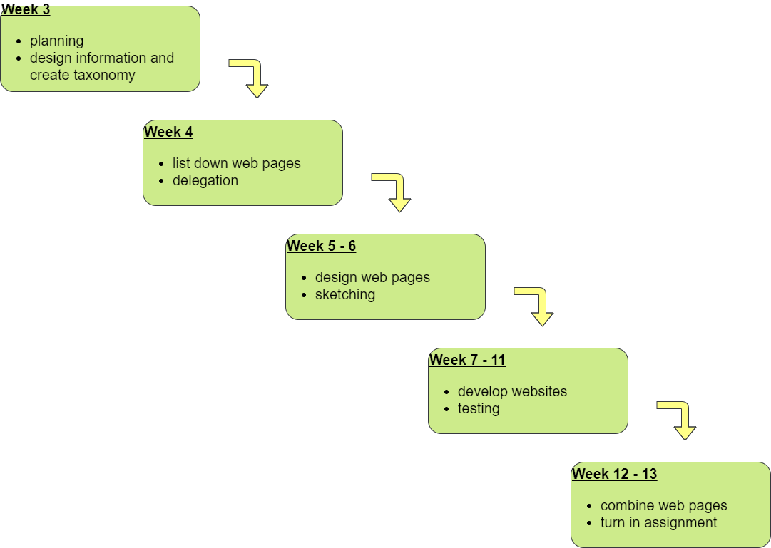

**CHAPTER 2: WEB ANALYSIS**

***Structure Chart***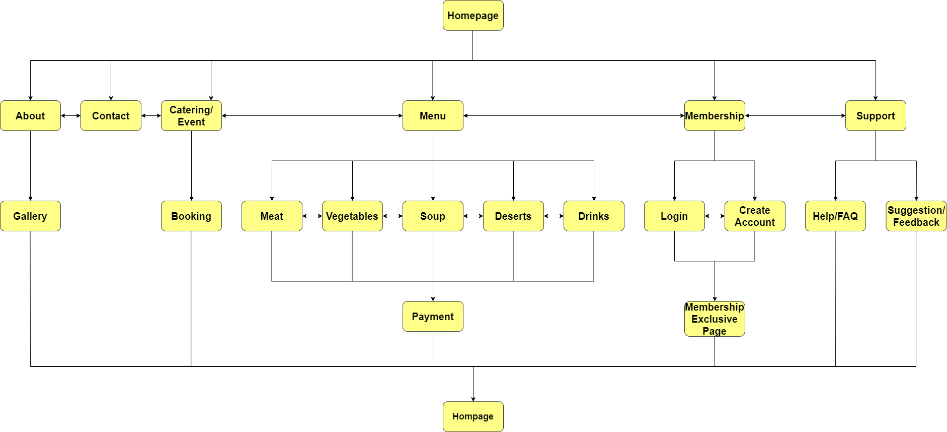

**Functions or Modules**

***Homepage***

This module is able to facilitate navigation to other pages on the site by providing links to prioritized and recent pages. For example, this module will be linked to the menu page, catering/event page, membership page, about us page, contact us page and support page.

***About us***

This module is able to link to two pages which is gallery and contact page. This module will describe more details to our customers about the main purpose of a glimpse into who you are as a person or a business. This module also communicates the story of our restaurant and how we started it.

***Gallery***

This module will show the gallery about the famous chefs who have visited our restaurant and give us some support. This page also can link to other modules like home, menu, events, membership, about us, contact us and support.

***Meat***

This page shows all the meats that are sold in this restaurant with their specific details and prices. Besides, The user can see his cart by clicking the cart’s button. In this cart, the user is able to change the quantity of food or remove the list from the cart. This page also can link to the other menu like vegetables, soup desserts and drinks page.

***Contact***

This page will display contact number, email address, and location of the restaurant. By clicking the telephone icon, the user can make a call and the user can also send an email l by clicking the mail icon. There is also a map below the location icon and address. It can link to google maps after clicking the map or the location icon. After that, it can link to social media’s websites such as facebook, twitter and instagram. When hovering the social media’s icons, it will display the name or id of the restaurant that is used in these social media. It can also link to other modules such as menu, event, membership, about us and support.

***Catering/Event***

This page will display all the events’ services that have been provided in this restaurant such as special events, corporate events and social events followed by their description, example and slideshow that shows the pictures of the event. After that, it can link to the booking's page by clicking the hyperlink below the events. It can also link to other modules such as homepage, menu, membership, about us, contact us and support.

***Booking***

This page allows the user to book a place in the restaurant for events or other purposes by submitting the booking form. The user is required to enter his name, email, contact number, date, starting and ending time, and number of people in this form for booking. Then, he can select the type of event he wants to book for. If the user wants booking for another purpose, he can select ‘other’ and input the detail beside the selection. After that, the user can input the comment about the event, service needed or something related to the booking in the comment’s text area. Lastly, this page can also link to other modules such as homepage, menu, event, membership, about us, contact us and support. After the booking form is submitted, it will link to another page that shows a success message with the hyperlinks that link to the contact and support page. Next, it can link back to the homepage by clicking the ‘back to homepage’ button.

***Vegetables***

This page shows all the vegetables’ dishes that are sold in this restaurant followed by their name, picture and price.When hovering over food’s boxes, it will display the stars that represent the recommendation index of the foods. If the user wants to see the description of the foods, he can click ‘view description’ to show the description. After that, the user can add to cart by clicking the buttons below the dishes. The user can also see his cart by clicking the cart's button. In this cart, the user can change the quantity of food and then it can link to payment’s page. After that, this page can also link to other modules such as homepage, menu, event, membership, about us, contact us and support.

***Menu***

This module is the main page for all dishes in our restaurant. It contains two sections, the first containing the title “Menu” and a search bar, while the second section contains links to all 5 categories of dishes available in our restaurant menu. The first section’s “Menu” title not only acts as a title of the page, but is also linked to the second section of the page, and the search bar below the title can be used to search between all the dishes currently available in our menu. The second section of the page displays a circle-shaped menu, evenly divided into 5 sectors, which are the 5 categories of dishes in our menu, namely Meat, Vegetables, Soups, Dessert and Drinks. Each sector has its own hover animation and is linked to their respective pages.

***Payment***

This module contains an overall summary of the user’s order and collects user input which allows users to make payments to their orders by submitting an input form. Upon entering this page, the user is prompted to choose between two payment methods, ‘Pay Online’ or ‘Cash on Delivery’. After the user has selected a payment method, two sections, namely ‘Order Summary’ and ‘Payment Details’ will be visible to the user. The Order Summary section displays a list of all ordered items and their respective image, description, quantity, price and subtotal, as well as a totals section that displays the subtotal of all items, the amount of delivery fee, taxes, and the final total amount at the end of the Order Summary section. On the other hand, the Payment Details section is a form which collects various input data from the user. The Payment Details section contains 3 smaller sub-sections, which are Customer Details, Credit Card Details and Other Details. The Credit Card Details section will show or hide depending on which payment method the user has chosen. The user can also choose to change its payment method if it wishes to. Lastly, a submit button which has a text of “Confirm Payment” and the final total amount need to be paid. Upon clicking the submit button, the user will be redirected to the payment receipt page, which will display a receipt of the latest payment the user had made. There are two sections in this receipt page, which are the "Customer Details" section and the "Receipt Details" section. The Customer Details section will display the name and address entered by the user at the payment screen, and the date of payment. Moreover, the Receipts Details section displays a list of bought items with their respective names, quantity, price and subtotal. There is also a totals section at the bottom showing totals details such as delivery fees, taxes and the final total. Lastly, at the bottom of the receipt, there's a "Return to Home Screen" button which will redirect the user to the home screen on click, and a “Print Receipt” button that will display a prompt to print this page.

***Membership***

This module is the main page of all of the membership pages and is responsible for allowing access to the login and register page. It contains two sections, the first section will prompt the user to choose between “Login” or “Create an Account” by displaying two big buttons. A small text “Why should I join?” is also displayed in this section which is linked to the second section of the page. The second section is responsible for explaining the benefits of becoming a member of our restaurant. There are 5 benefits listed in total, in which each will expand themselves when the user hovers on them as a sign of emphasis.

***Soups***

This module is one of the subcategories of the “Menu” module, and it contains three sections. The first section shows the “Soup” title, which will bring the user to the second section of the page when clicked. The second section displays all available soup dishes in 3 pages, up to 6 dishes each page. Upon clicking on any soup dish, an overlay covering the whole screen will show up and display the soup in detail. This overlay contains the soup’s name, price, image, description, and an Add to Cart button. The add to cart button will add the specific soup dish to the user’s cart, which will be able to be carried to the payment page for the payment to be made. The third section contains links that redirect the user to other subcategories of the “Menu” module, which are Meats, Vegetables, Dessert and Drinks.

***Login***

This module is one of the sub-categories of the “membership ” module. This module allows users to login into their account for further functions such as membership exclusive. When the user clicks on the submit button it will validate the data input to make sure it is the same with the registered one and jump to membership exclusive page.

***Create Account***

This module is one of the sub-categories of the “membership” module . This allows users to create an account . When clicking on the register button, it will validate the data input by the user to make sure the data input is valid and jump to the login page.

***Membership Exclusive Page***

This module is the sub-categories of the “login” and “create account” module. It provides a lot of rewards ( promotion ) on that month , this can help to increase the customers return to the restaurant. It also has some basic information about the customer and the recent purchase on this page .

***Desserts***

This page shows all the desserts that are sold in this restaurant followed by their details and prices. After that, the user can add to cart by clicking the buttons below the dishes. The user can also see his cart by clicking the cart's button. In this cart, it can link to payment’s page. Besides, this page can also link to other modules such as menu, event, membership, about us, contact us and support.

***Support***

This module is linked to the help module and suggestion module. Besides that, users can also input their problems or questions here. By clicking the L’ovest 69, users can link to the home page.After users submit their problem it will pop up a message about the user successfully submitting their problem. Menu, events, home, membership, about us, contact us,and support modules also be linked to this module.

***Help/FAQ***

This module enables us to solve users’ problems and questions. This is because users can type out their problem or question here. When users input their problems, they are also required to give their ID name and email and will display a message saying users are successfully submitting their problems. Not only that, in this module we also provide several questions that are often asked by users.The title of that question also be linked to that page.For example, when users clicked title like booking users can be linked to booking module. Users can click on the contact number and email that will automatically be linked to users’ computer mail app or phone. It is also linked to others modules such as menu, events, home, membership, about us, contact us and support.

***Suggestion/Feedback***

This module allows users to give their suggestions or feedback for L’ovest 69. When users input their suggestion or feedback, they are required also to input their ID name and email. After users submit their problem it will pop up a message about the user successfully submitting their problem. Not only that, this module also has provided some questions for users to give their feedback. For example, did users think that our service is awesome, excellent, satisfactory, marginal, or poor. Besides that, this module can also be linked to another module such as menu, events, home, membership, about us, contact us, and support modules.

***Drinks***

This module has two pages showing all the drinks that are sold in L’ovest 69 followed by their descriptions and prices. After that, the user can add to cart by clicking the add to cart button below the drinks. Users can also see their cart by clicking the cart's button. In the cart, it can link to payment’s page for easier users to pay. When users hover over the product name, it will show that product is a best seller for a few products. Not only that, product name and price will show in the product image when users hover over the product image. Besides that, this page can also link to other modules such as menu, event, membership, about us, contact us, meat, vegetable, soup, dessert and support.

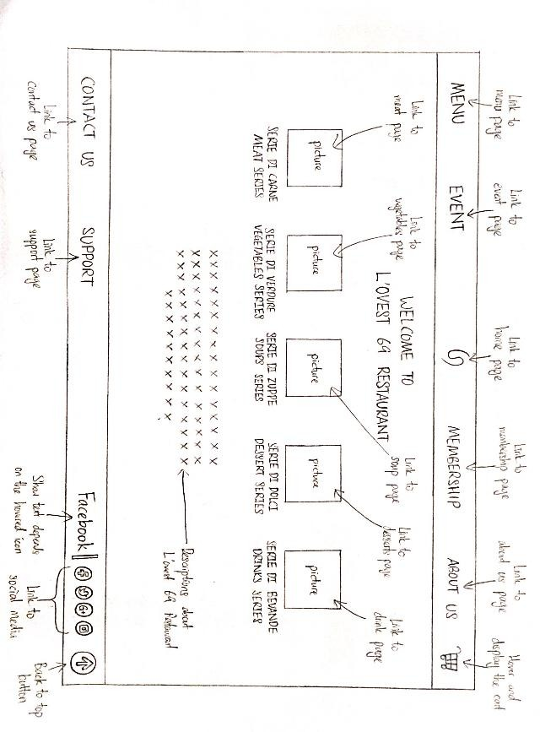**Chapter 3: WEB DESIGN**

**Web Pages Sketching**

**Homepage**

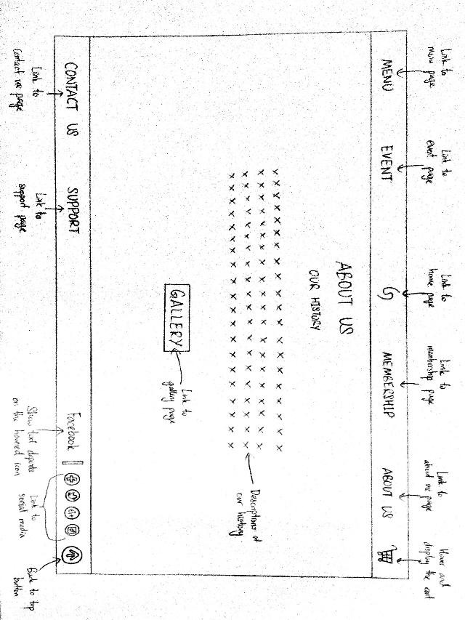**About us**

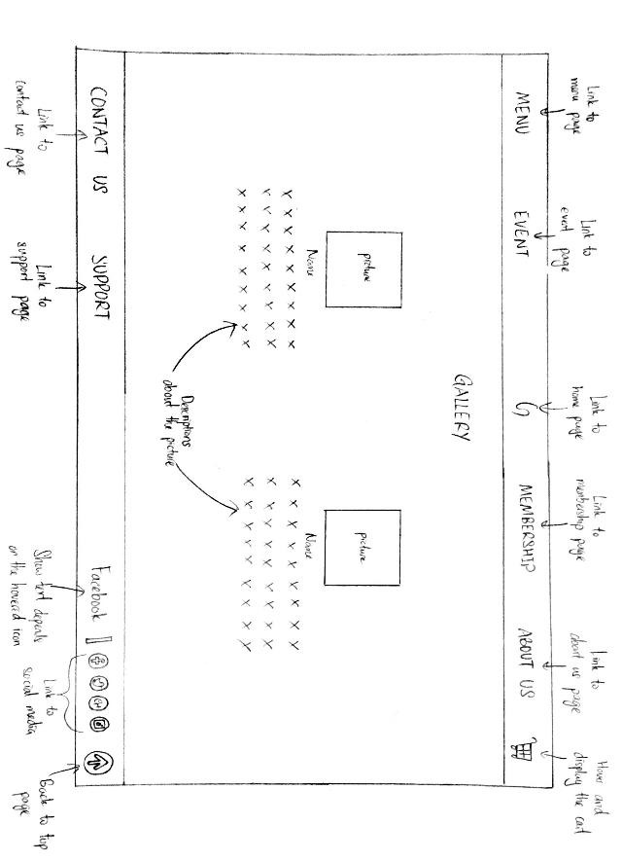**Gallery**

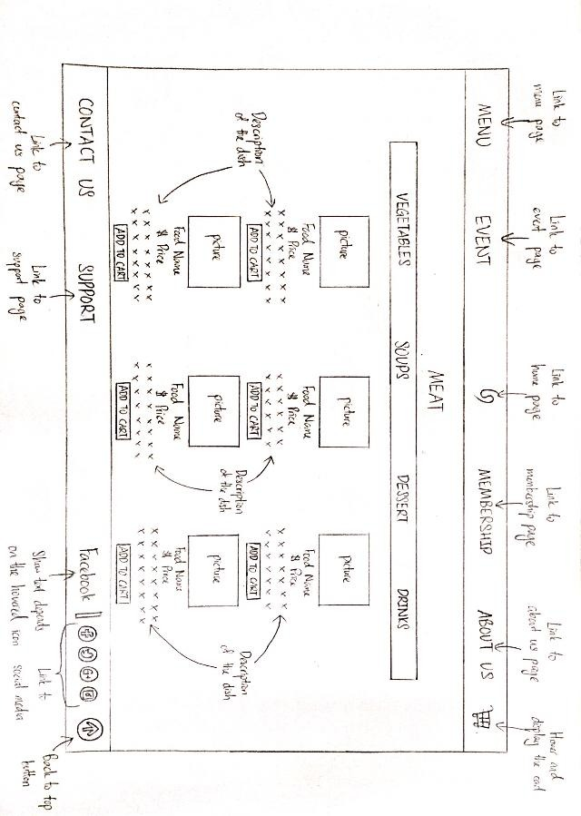**Meat**

**Contact**

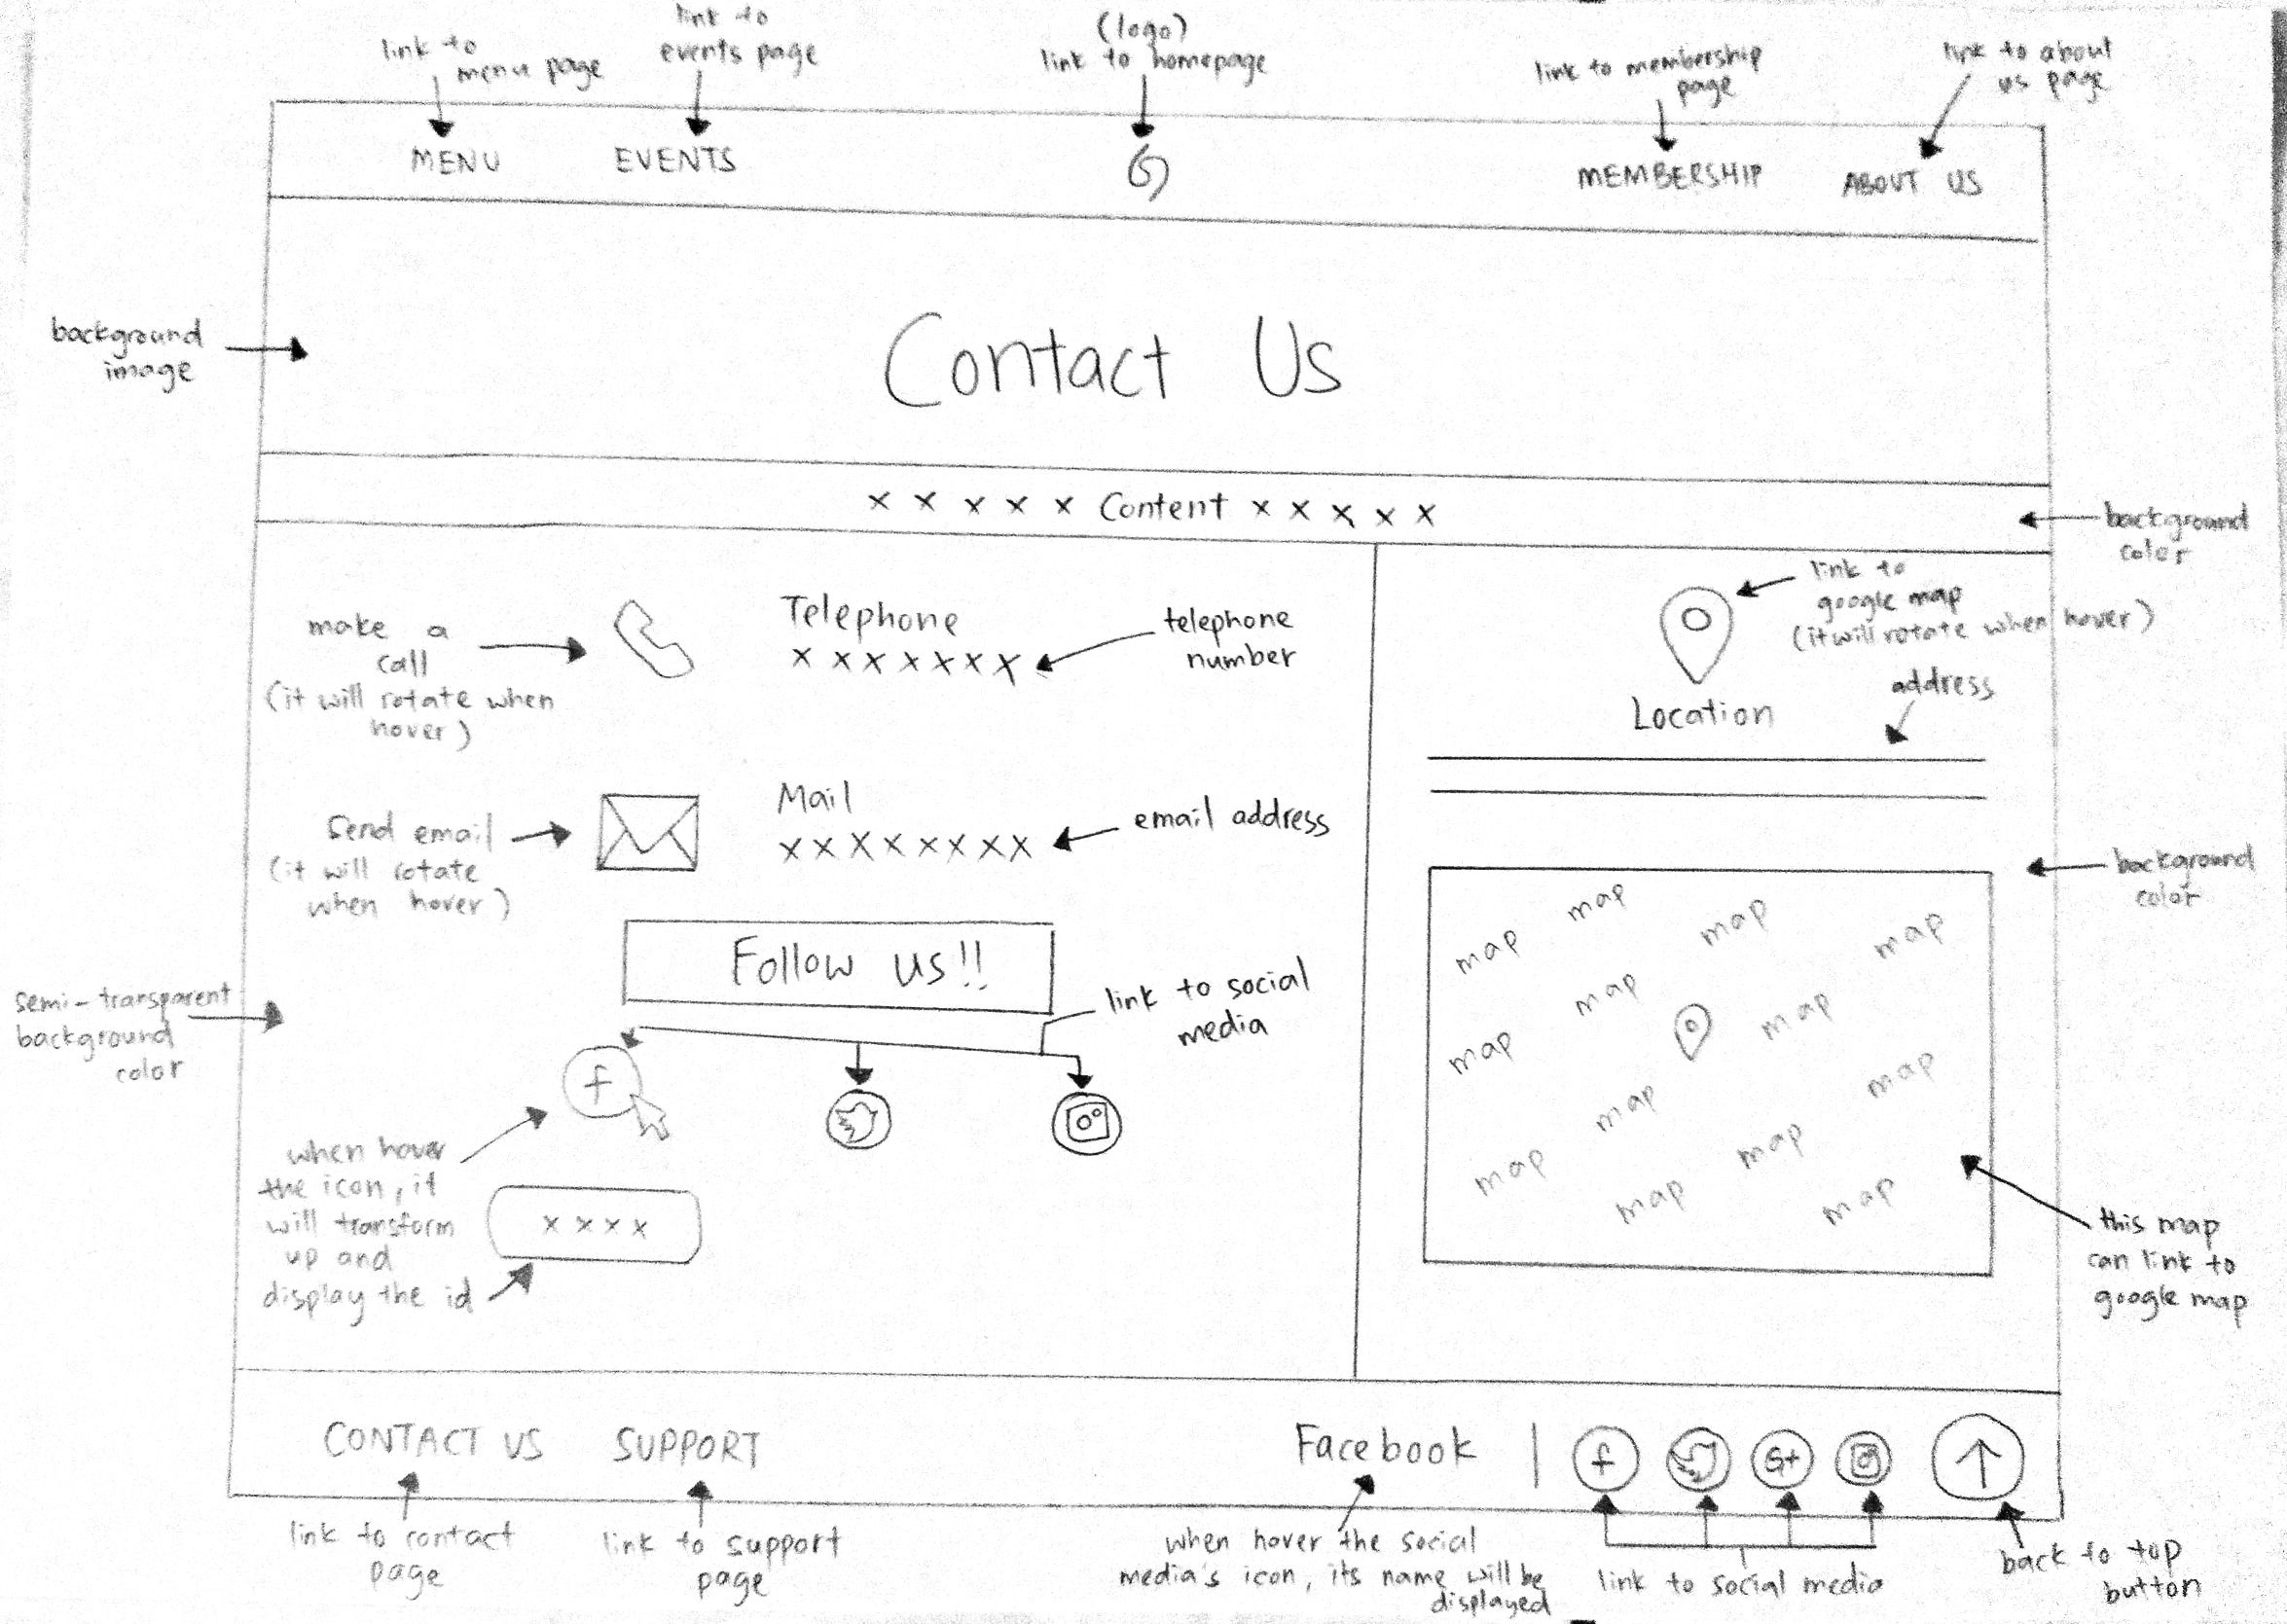

**Catering/Event**

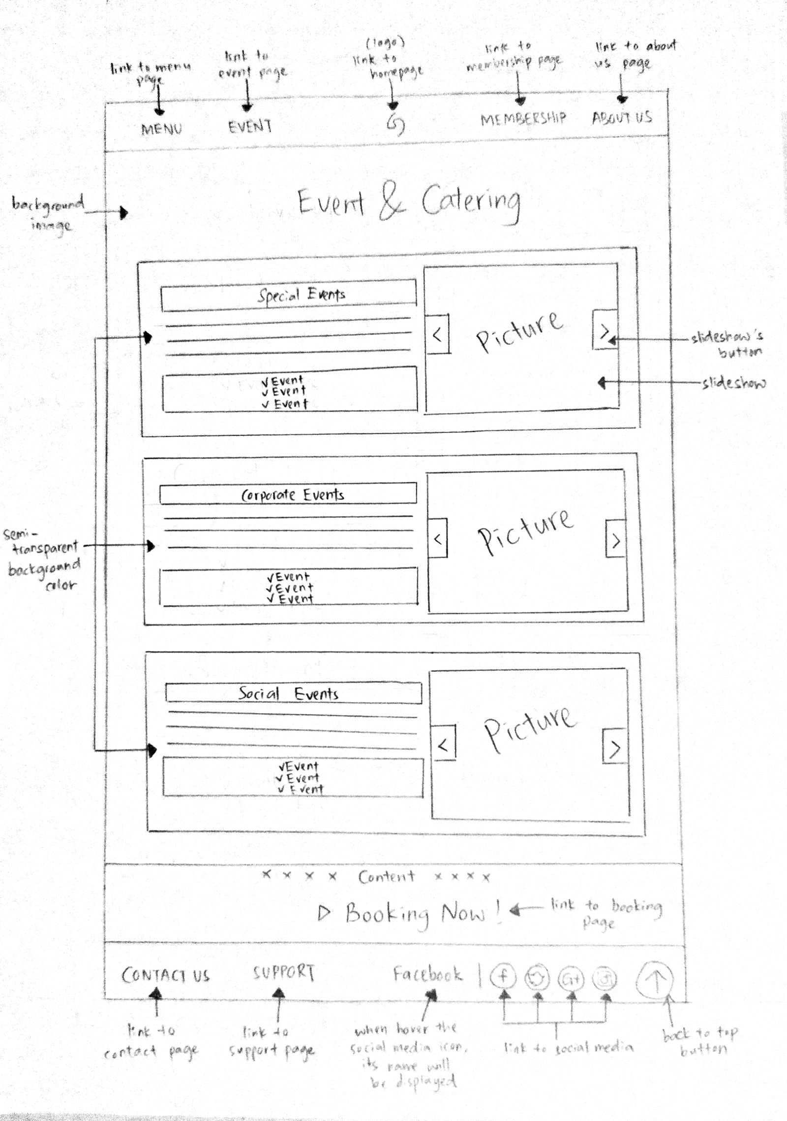

**Booking**

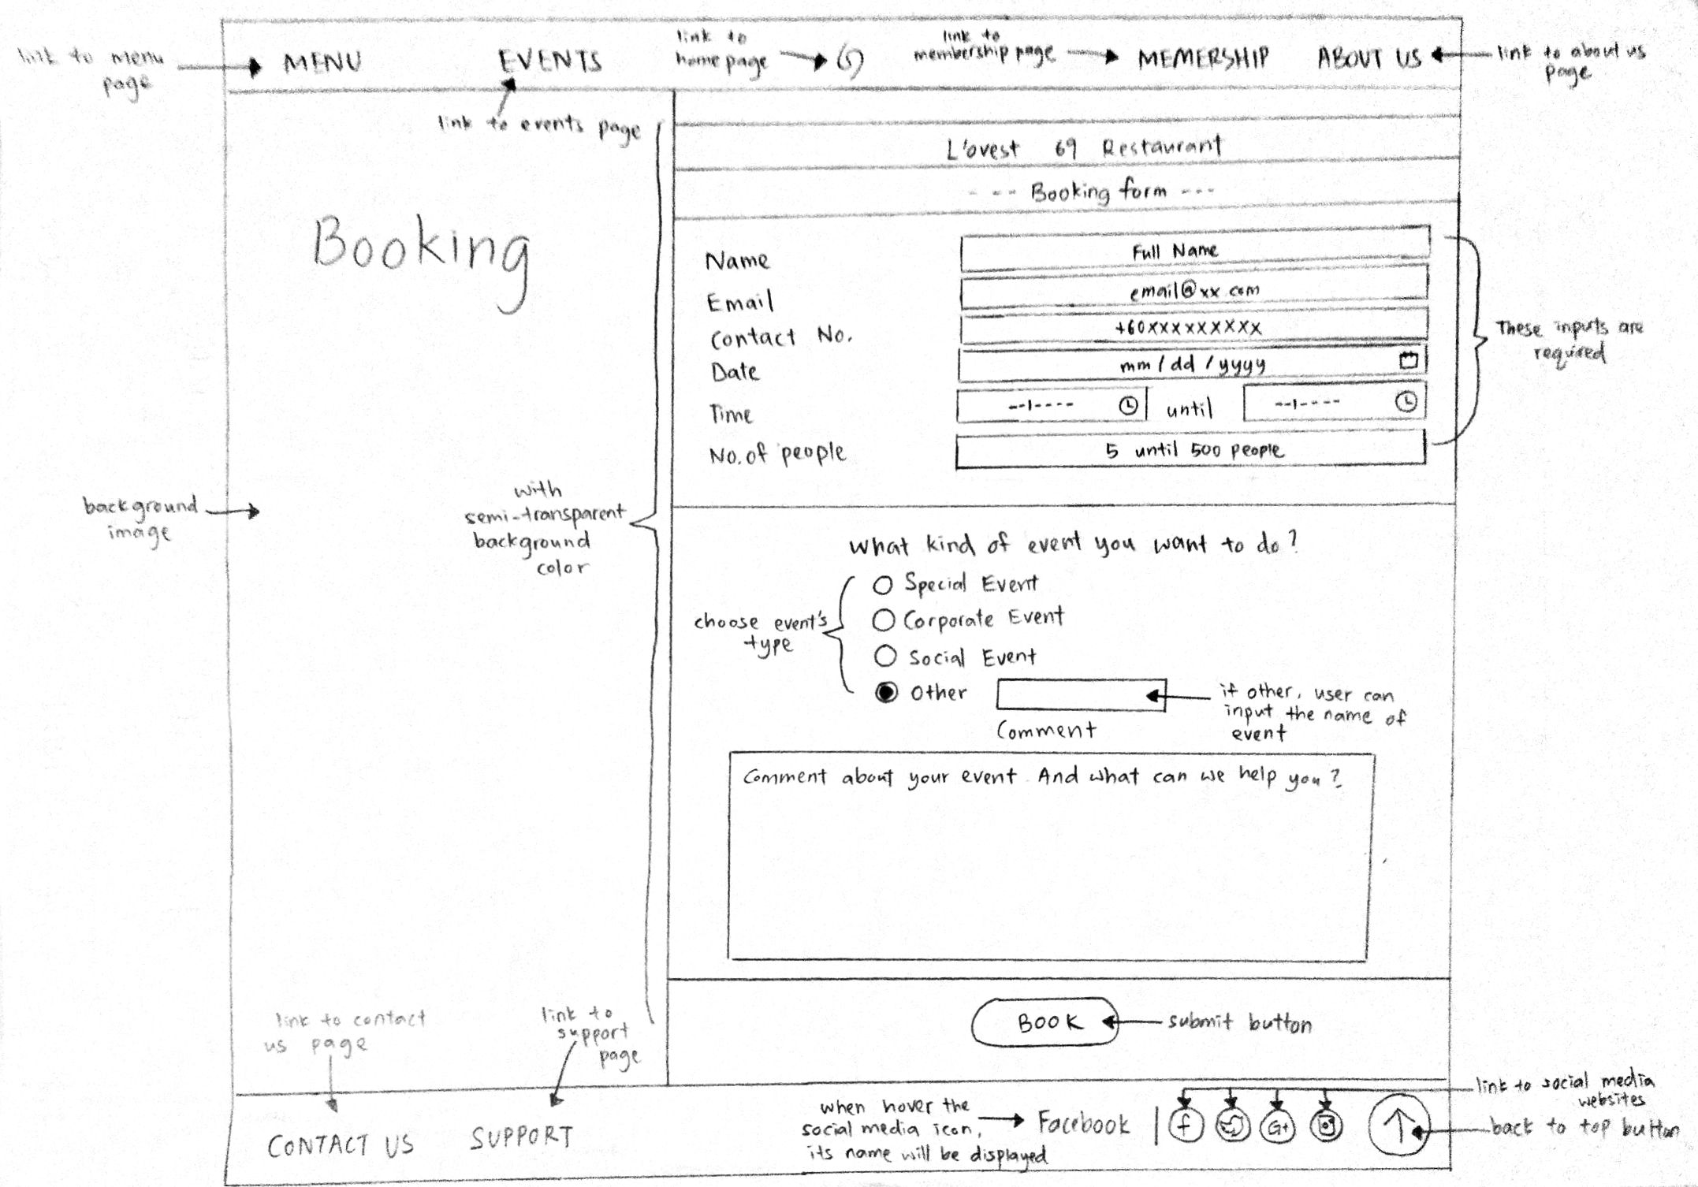

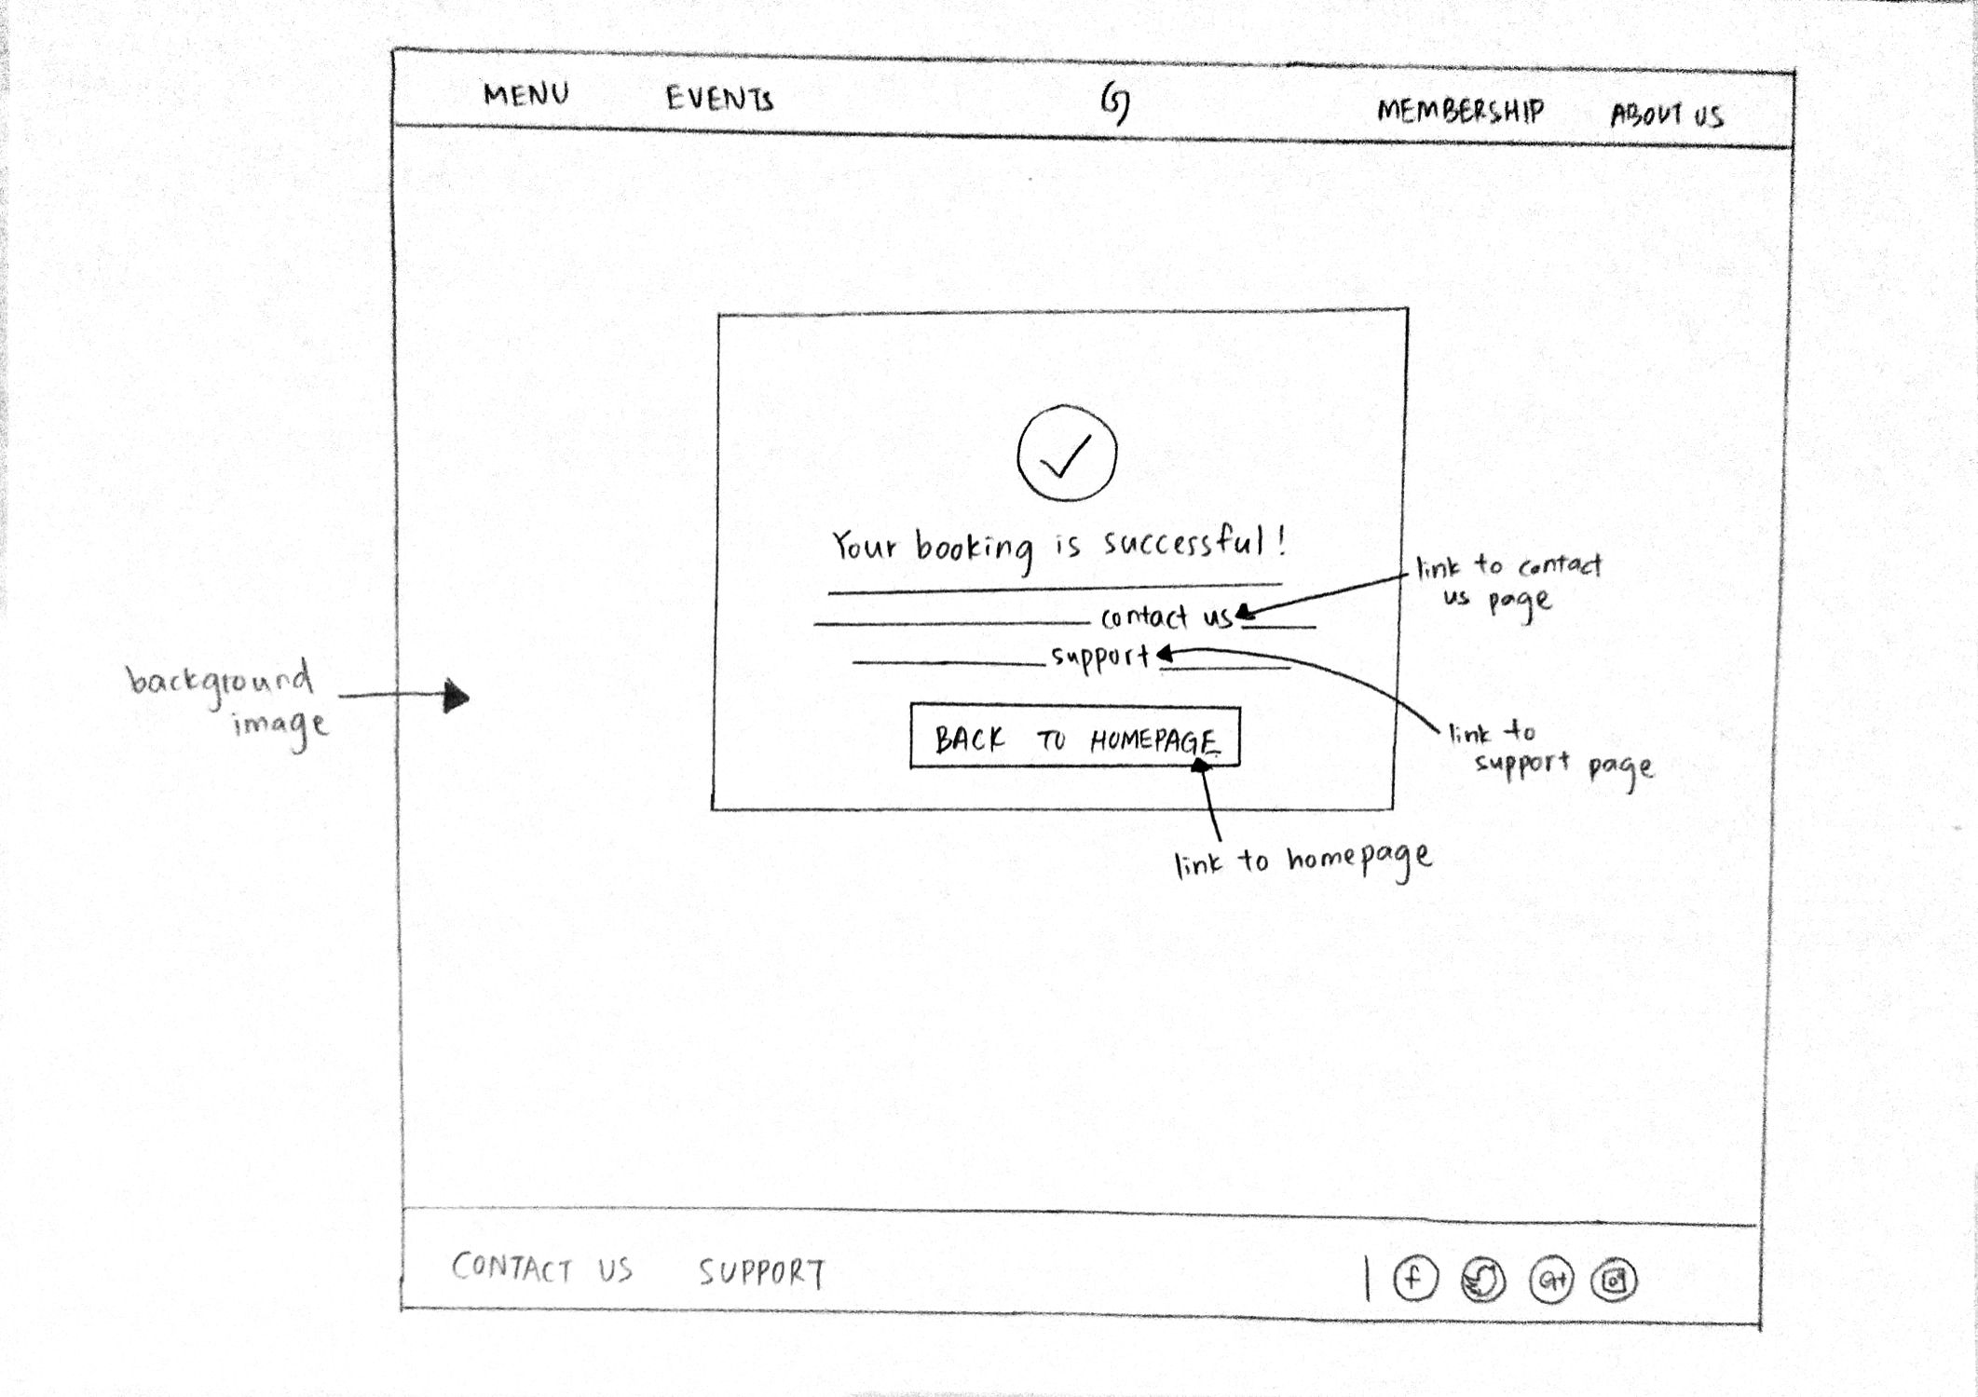

**Vegetables**

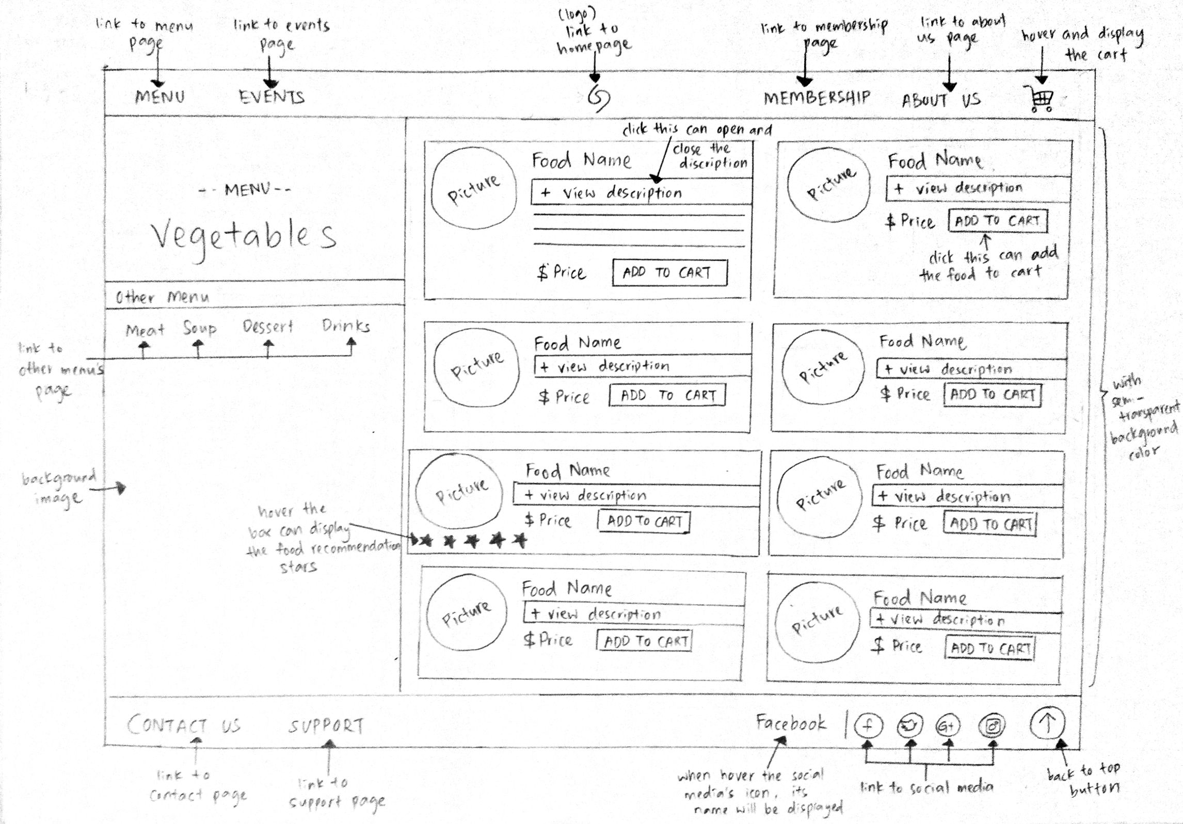

**Menu**

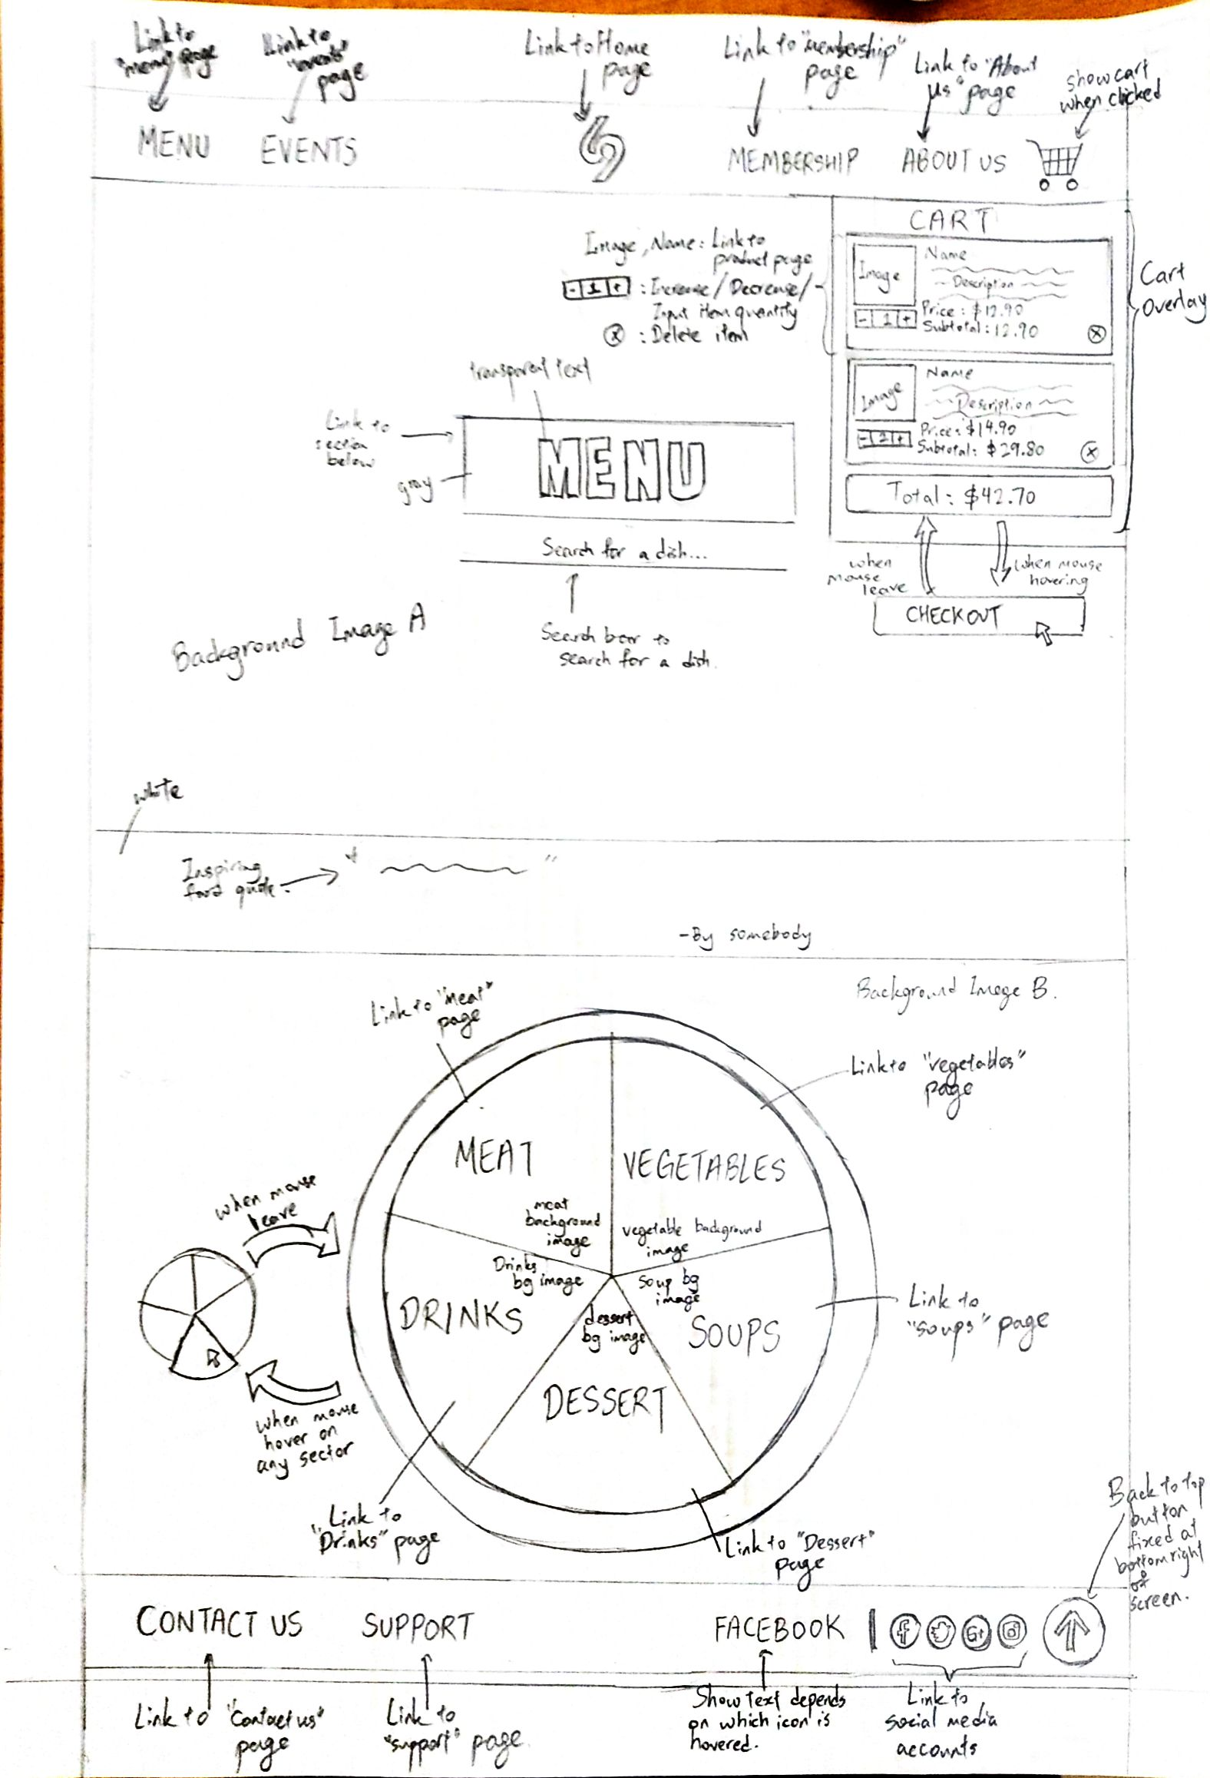

**Payment**

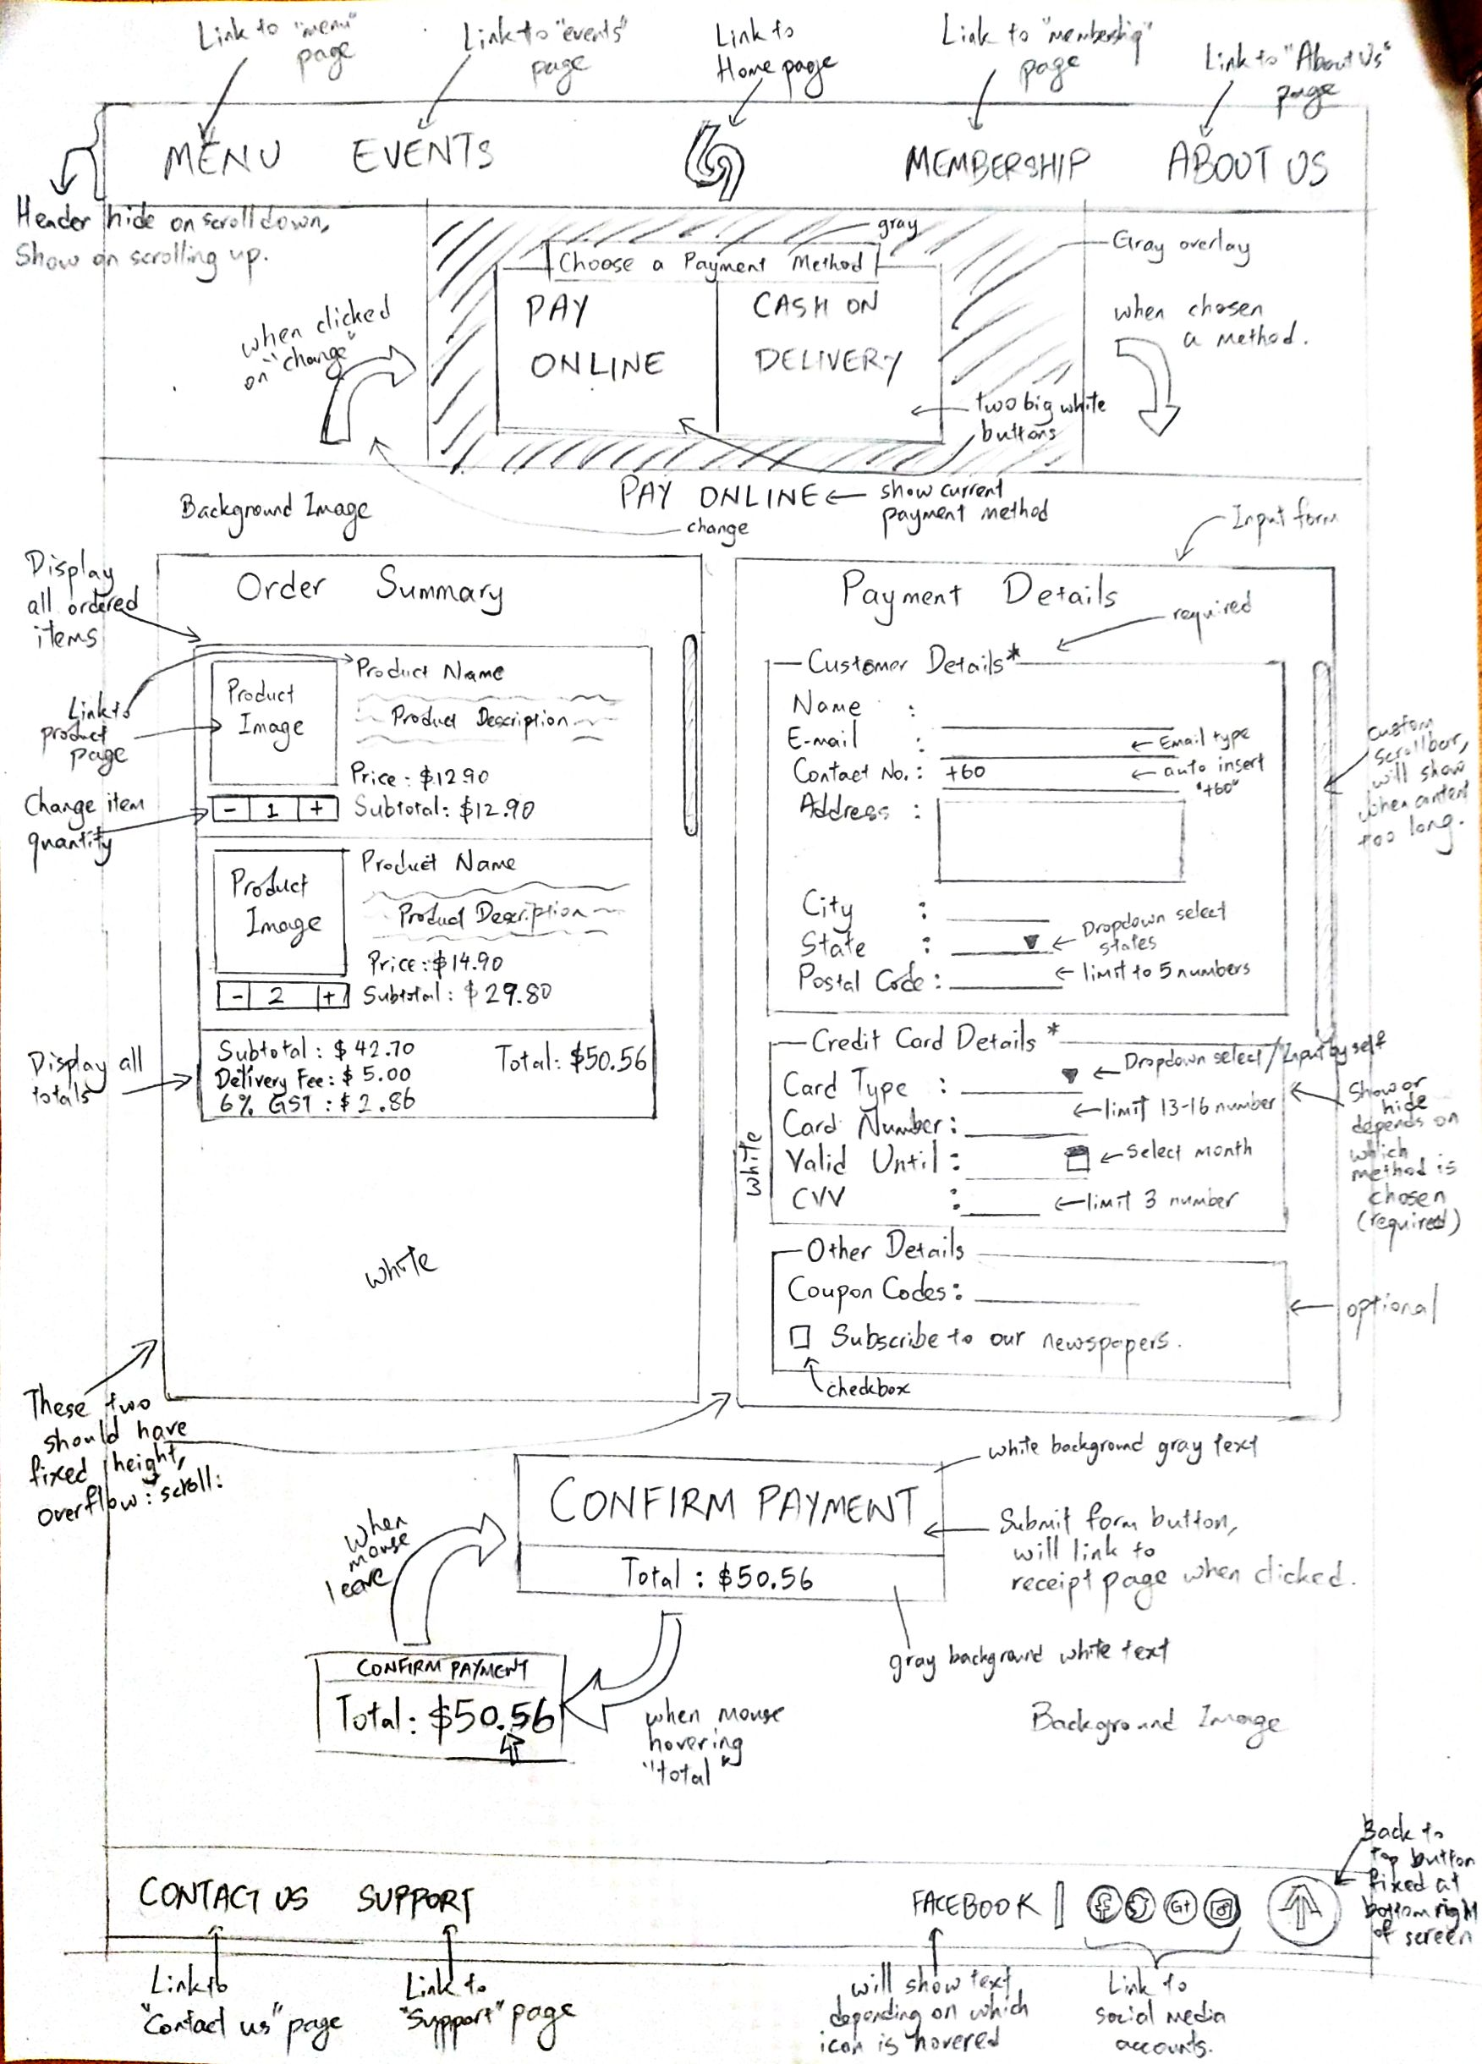

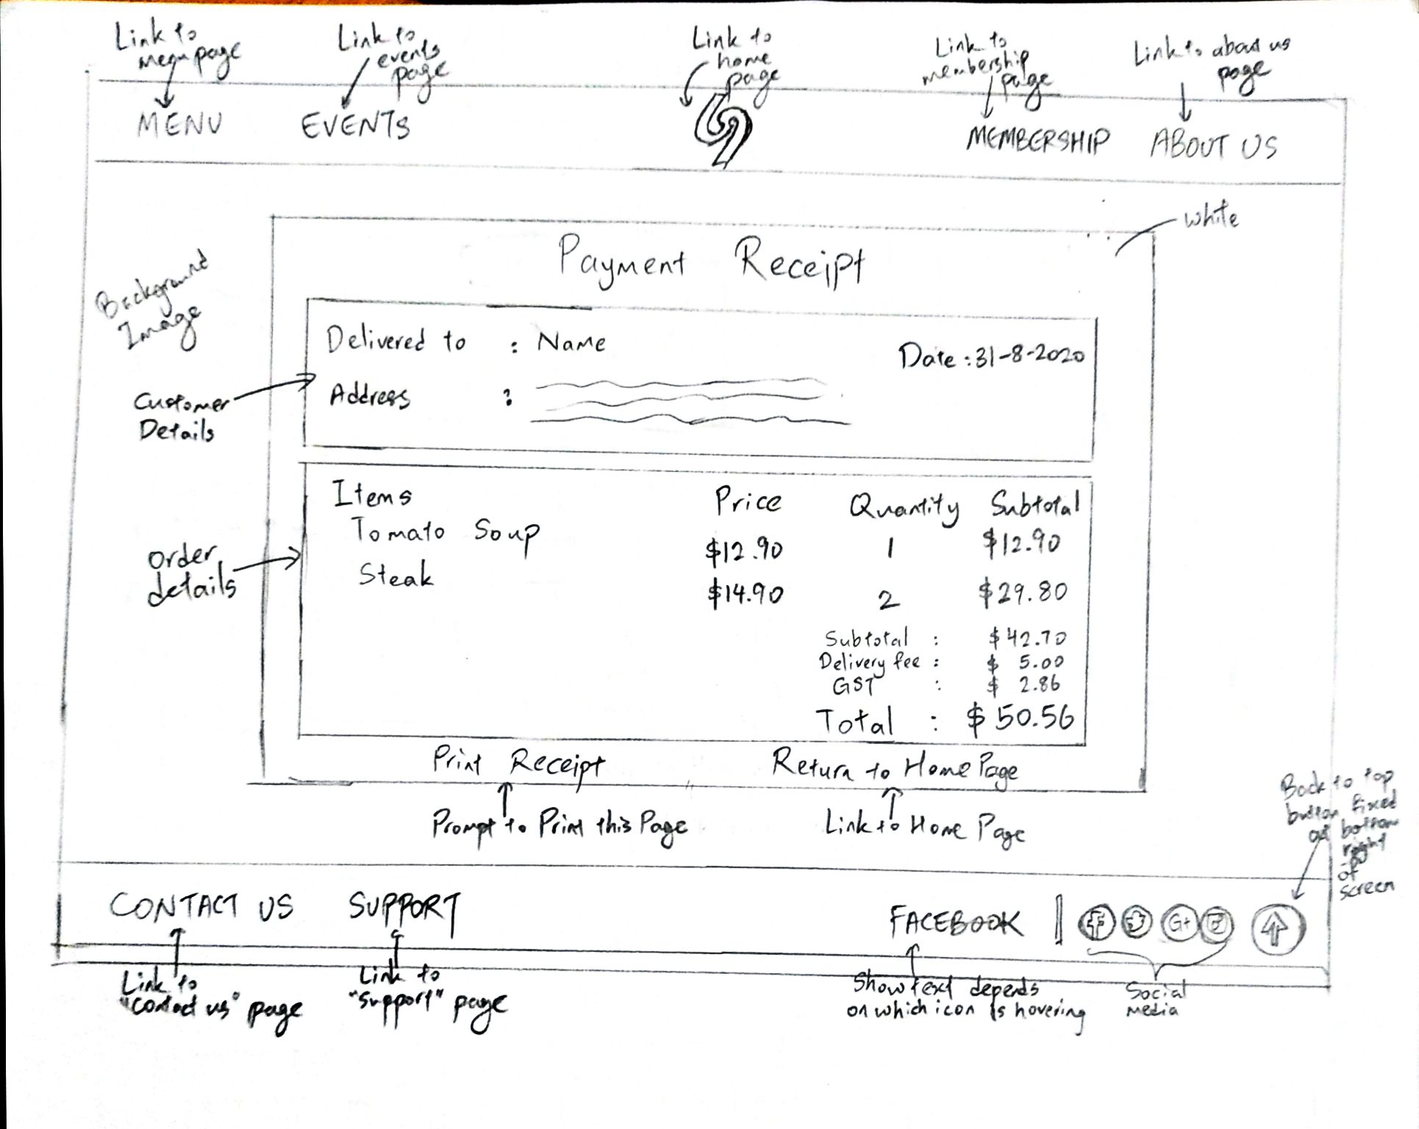

**Membership**

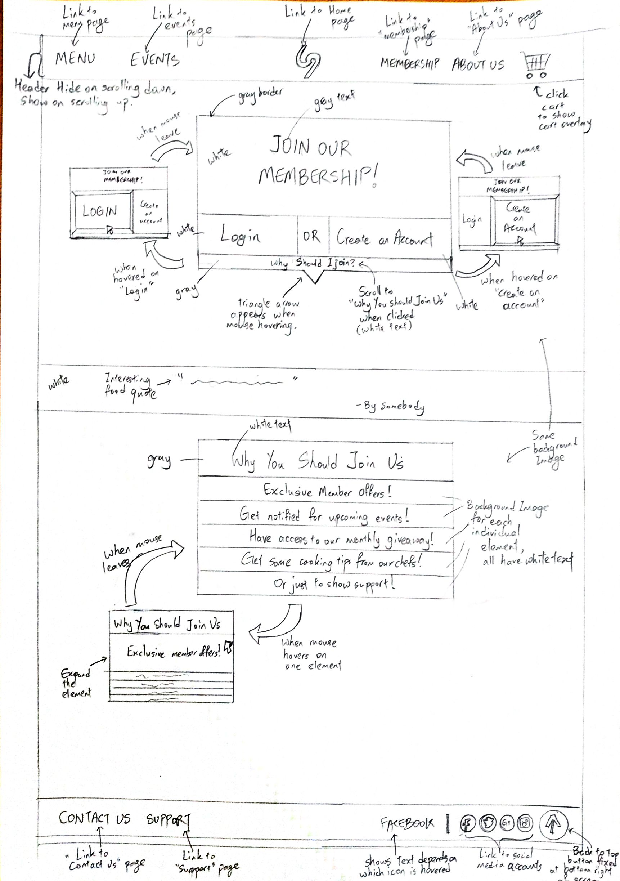

**Soup**

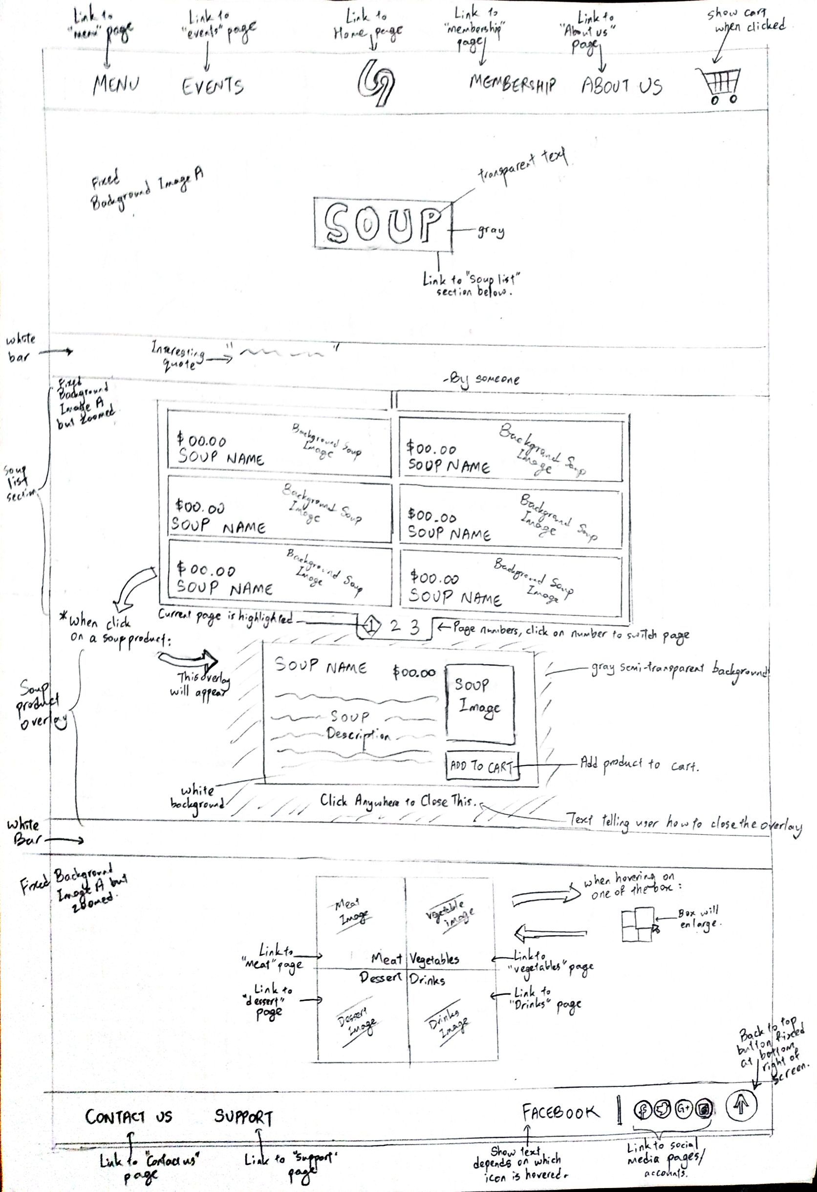

**Login**

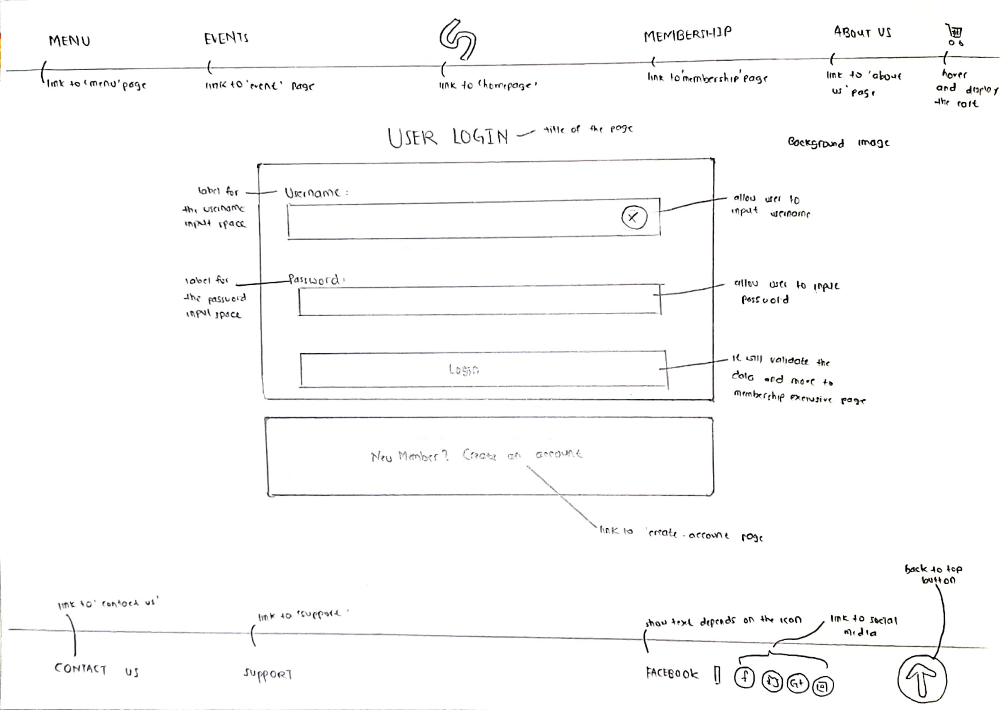

**Create Account**

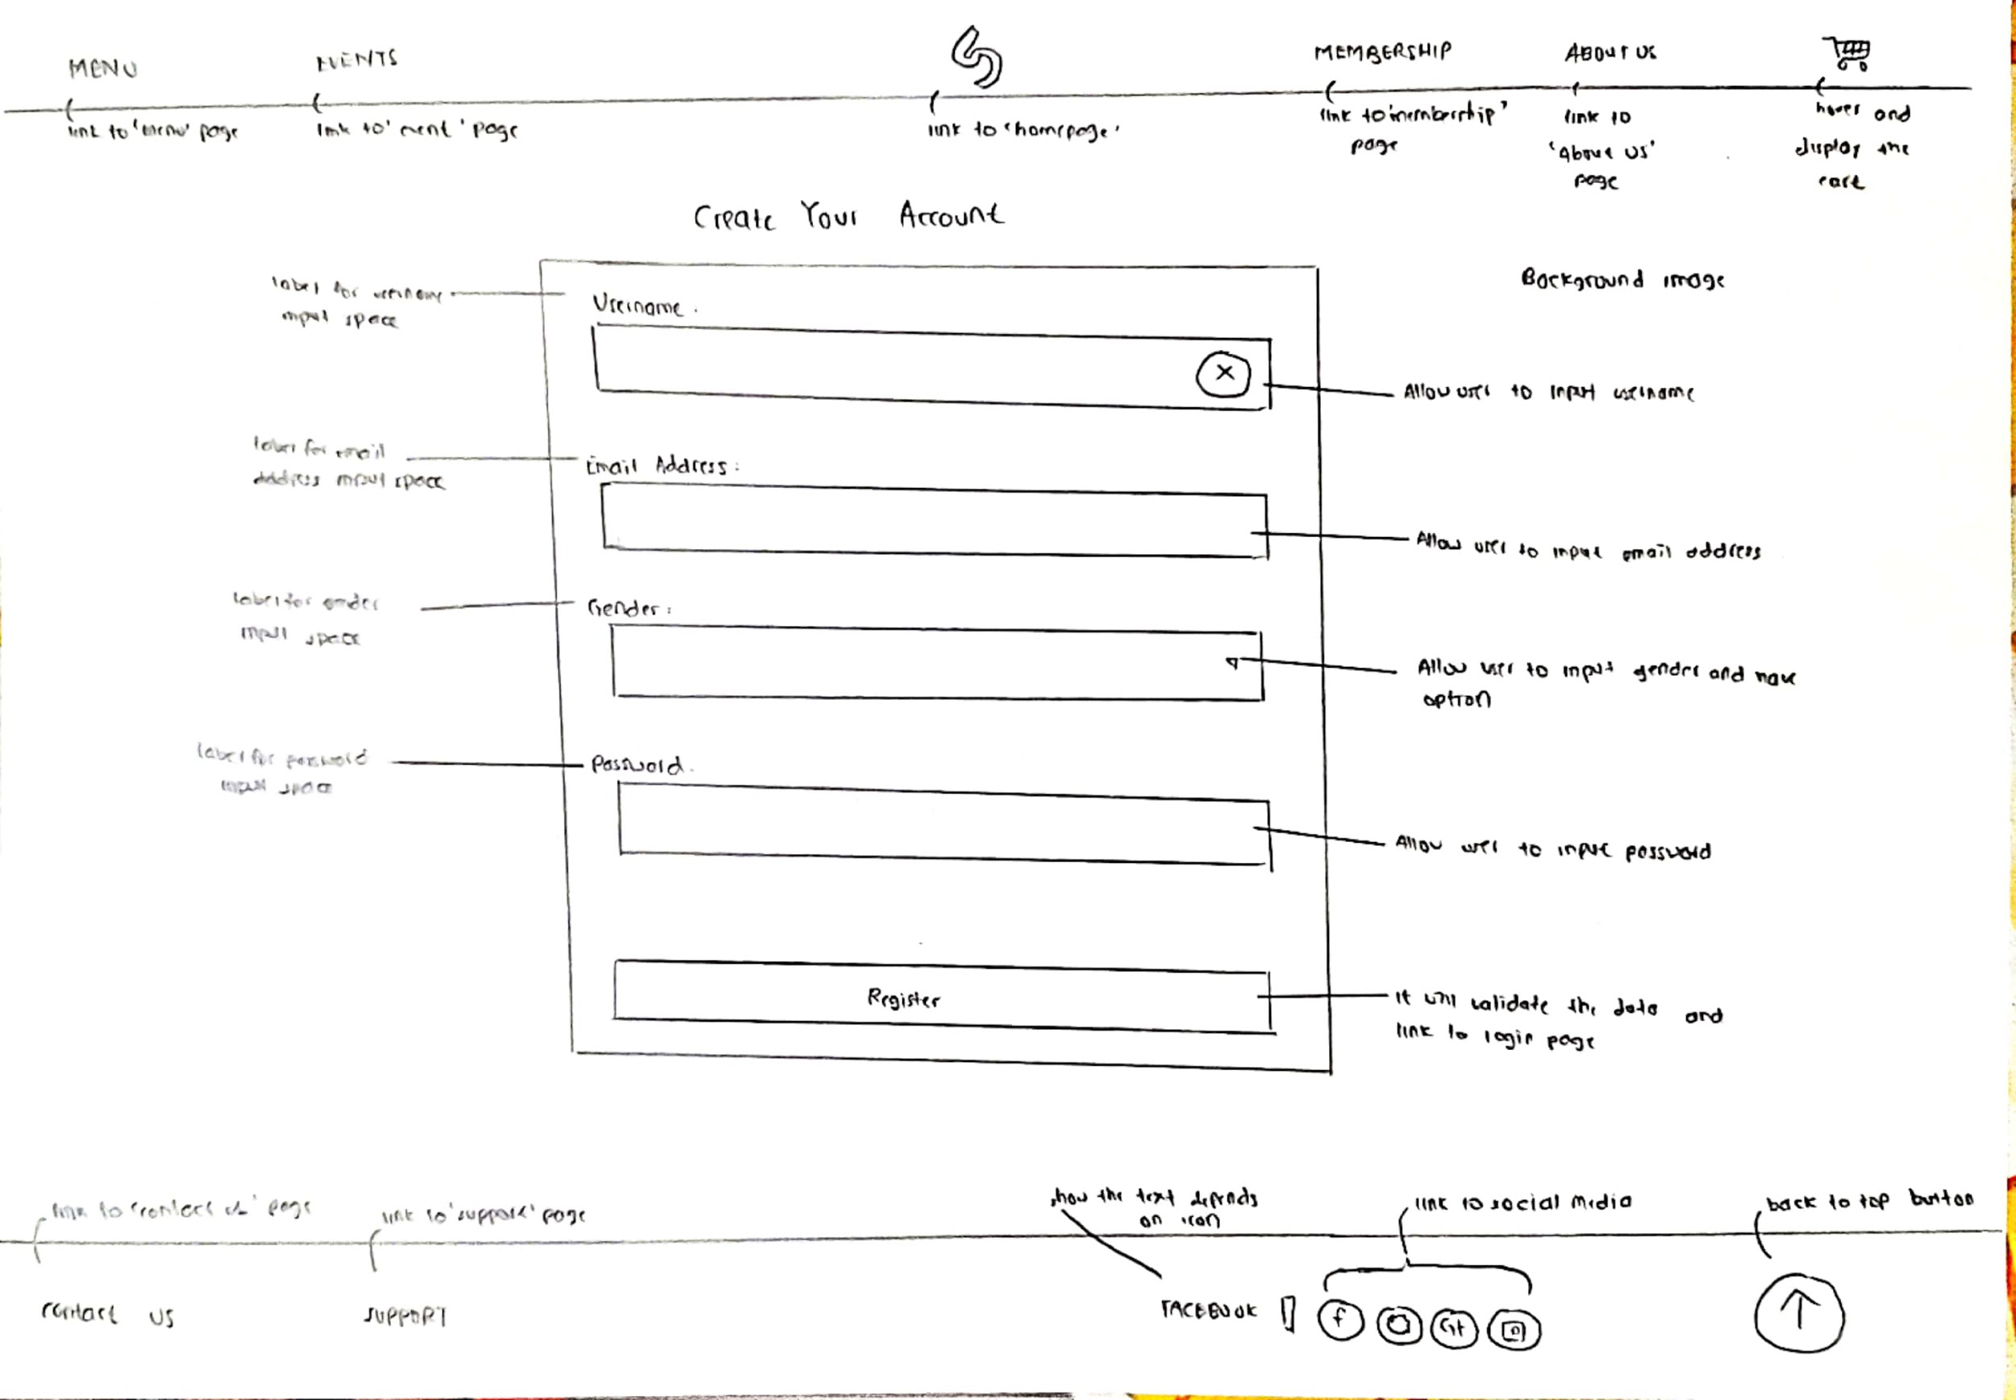

**Membership Exclusive Page**

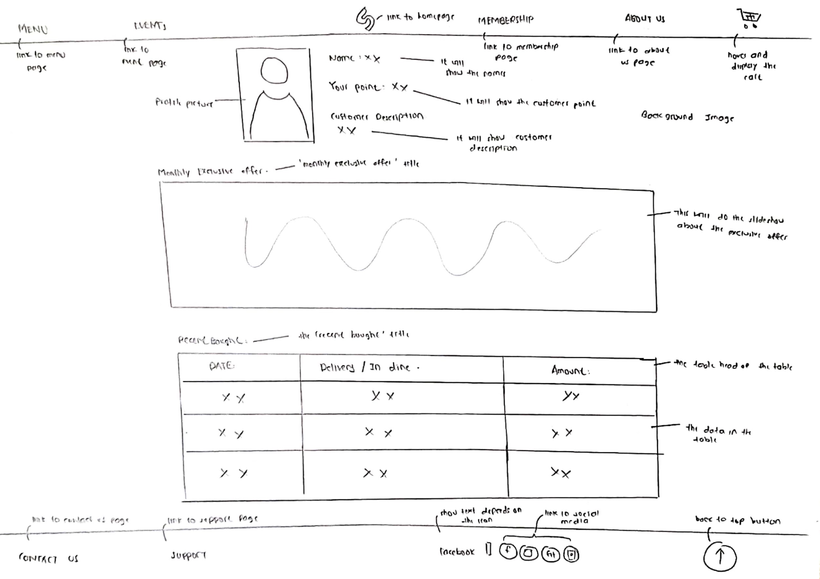

**Desserts**

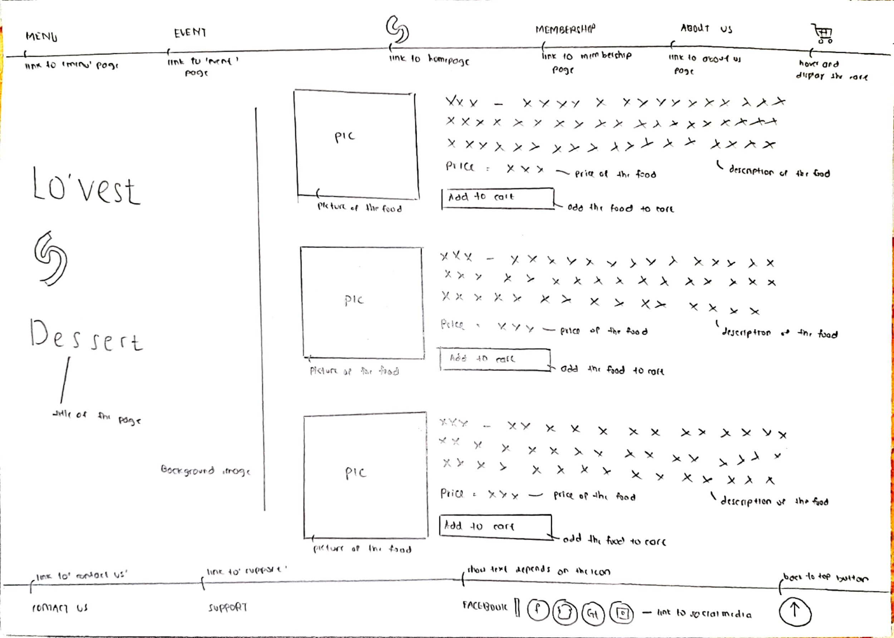

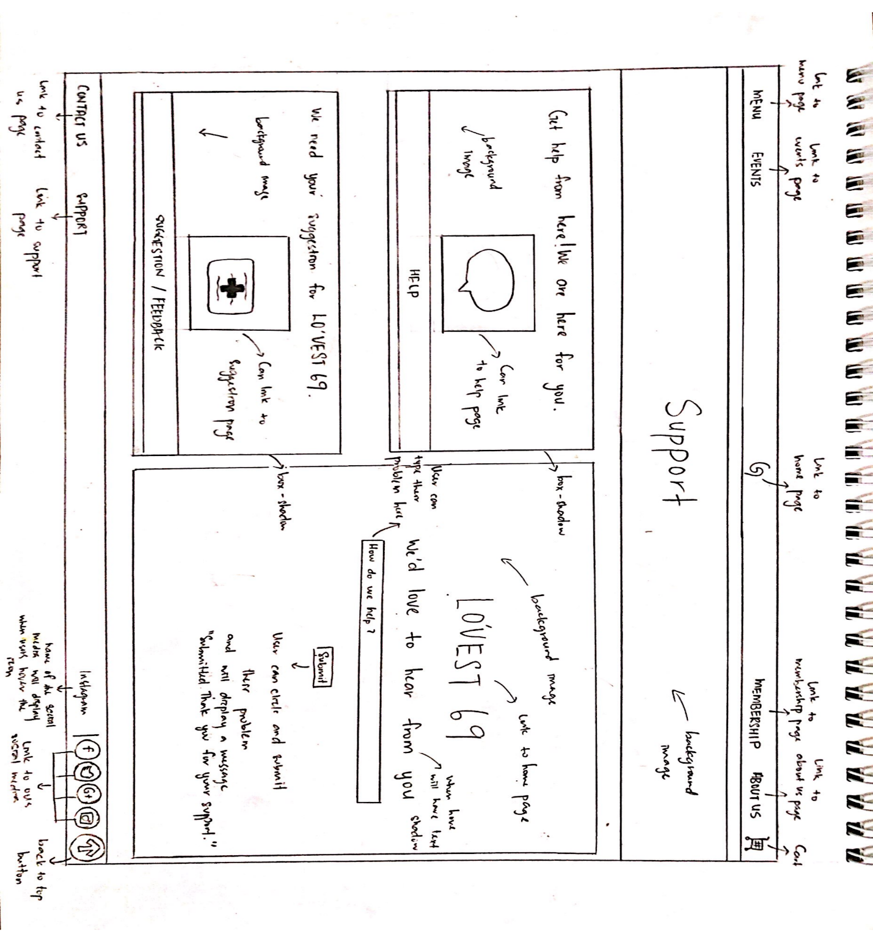**Support**

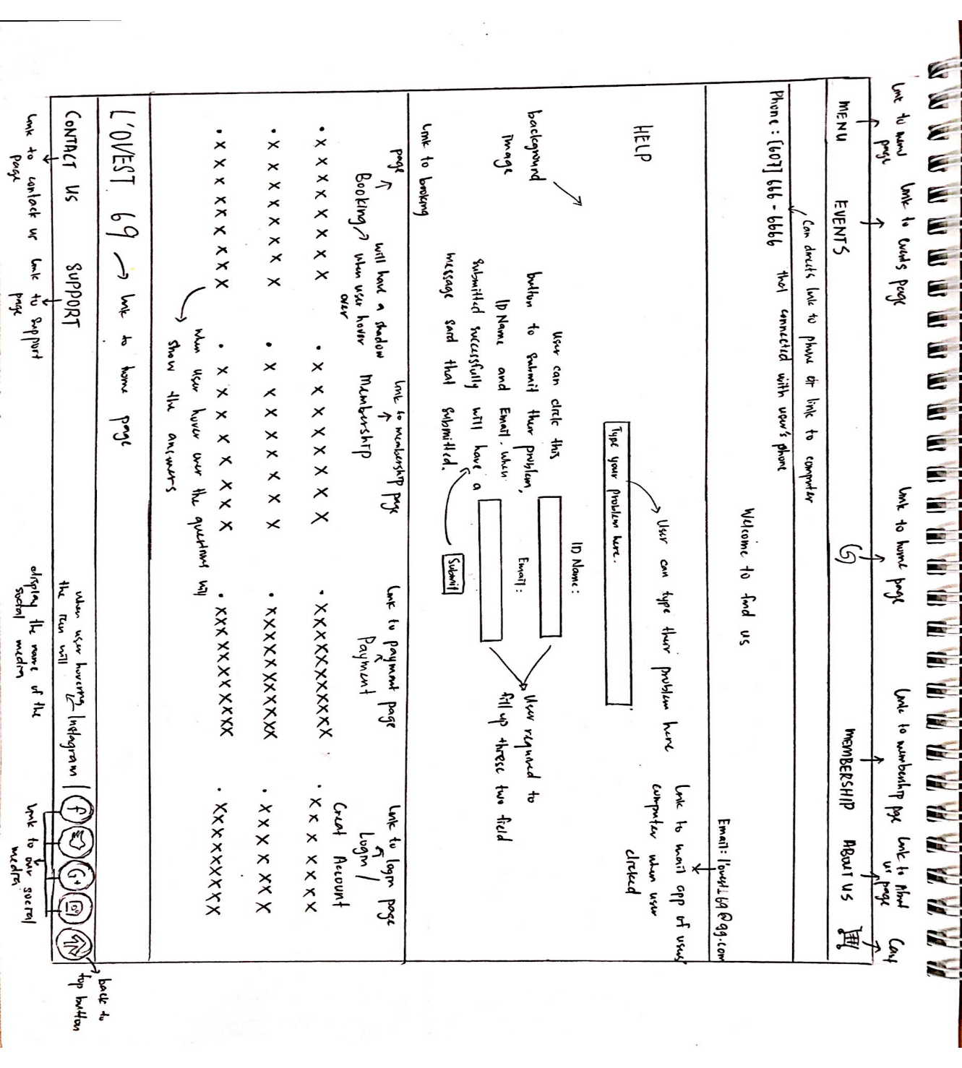**Help/FAQ**

**Suggestion/Feedback**

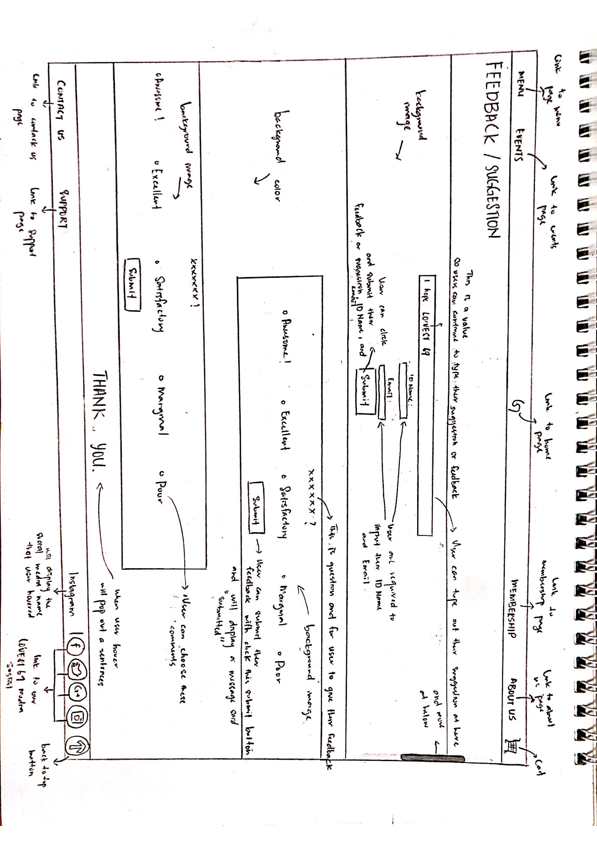

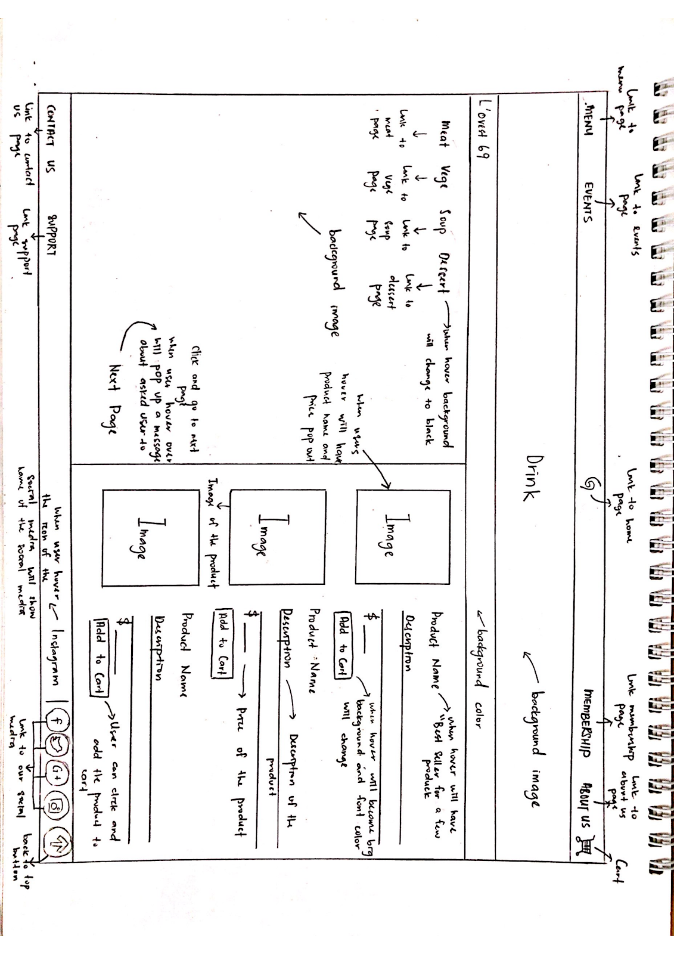**Drinks**

**References**

* W3schools.com, (2000). W3Schools Online Web Tutorials. [online] Available at: <https://www.w3schools.com/> [Accessed 2 Aug 2020].
* Pixel-industry.com, (2016). Royal Plate - Restaurant & Catering HTML Template. [online] Available at: <http://www.pixel-industry.com/html/royal-plate/catering.html> [Accessed 20 Aug 2020].
* Between the Bread | Full service catering and eateries in NYC(2000). Get inspired | Between the Bread in NYC. [online] Available at: <https://www.betweenthebread.com/get-inspired/> [Accessed 20 Aug 2020].
* De.Wan 1958 by Chef Wan, (2019). Events - De.Wan 1958 by Chef Wan | Wedding | Corporate | Art | Fashion. [online] Available at: <https://dewan.space/events/> [Accessed 20 Aug 2020].
* Pinterest, (2010). Keterangan foto tidak tersedia. | Desain logo, Desain, Gambar. [online] Available at: <https://www.pinterest.com/pin/829506825098629290/> [Accessed 2 Aug 2020].
* En.wikipedia.org, (2004). List of vegetable dishes. [online] Available at: <https://en.wikipedia.org/wiki/List_of_vegetable_dishes>
* Google.com, (2001). Google images. [online] Available at: <https://www.google.com/imghp?hl=EN> [Accessed 20 Aug 2020].
* En.wikipedia.org, (2001). List of soups - Wikipedia. [online] Available at: <https://en.wikipedia.org/wiki/List_of_soups> [Accessed 5 Aug. 2020].
* Jotform, (2012). 10,000+ Free Online Form Templates & Form Examples | JotForm. [online] Available at: <https://www.jotform.com/form-templates/> [Accessed 18 Aug. 2020].
* Stackoverflow.com, (2008). Stack Overflow - Where Developers Learn, Share & Build Careers. [online] Available at: <https://stackoverflow.com/> [Accessed 6 Aug. 2020].
* Developer.mozilla.org, (2005). MDN Web Docs. [online] Available at:  <https://developer.mozilla.org/en-US/> [Accessed 8 Aug. 2020].
* Unsplash.com, (2013). Beautiful Free Images & Pictures | Unsplash. [online] Available at: <https://unsplash.com/> [Accessed 12 Aug. 2020].
* Pexels.com, (2014). Free stock photos · Pexels. [online] Available at: <https://www.pexels.com/> [Accessed 12 Aug. 2020].
* Pixabay.com, (2005). 1.8 million+ Stunning Free Images to Use Anywhere - Pixabay. [online] Available at: <https://pixabay.com/> [Accessed 12 Aug. 2020].
* Askideas.com, (2013). Askideas.com | Ask Ideas About Tattoos, Piercing, Food, Health, Fashion, etc. [online] Available at: <https://www.askideas.com/> [Accessed 22 Aug. 2020].
* Youtube.com, (2005). YouTube. [online] Available at: <https://www.youtube.com/> [Accessed 6 Aug. 2020].
* Codepen.io, (2015). CodePen: Build, Test, and Discover Front-end Code. [online] Available at: <https://codepen.io/> [Accessed 6 Aug. 2020].
* Seriouseats.com, (2008). *Introduction To French Macarons*. [online] Available at: <https://www.seriouseats.com/2007/10/introduction-to-french-macarons.html> [Accessed 7 August 2020].
* Pngtree, (2017). *Millions Of PNG Images, Backgrounds And Vectors For Free Download | Pngtree*. [online] Available at: <https://pngtree.com/>  [Accessed 16 August 2020].
* Allrecipes.co.uk, (2012). *Reviews And Comments For Blueberry Cheesecake - All Recipes UK*. [online] Available at: <http://allrecipes.co.uk/recipe/2765/reviews-comments.aspx>  [Accessed 16 August 2020].
* Shutterstock.com, (2004) Shutterstock image [online] Available at: <https://www.shutterstock.com/home> [Accessed 31 August 2020].
* En.wikipedia.org, (2004). List of steak dishes. [online] Available at: <https://en.wikipedia.org/wiki/List_of_steak_dishes> [Accessed 31 August 2020]

**Drinks**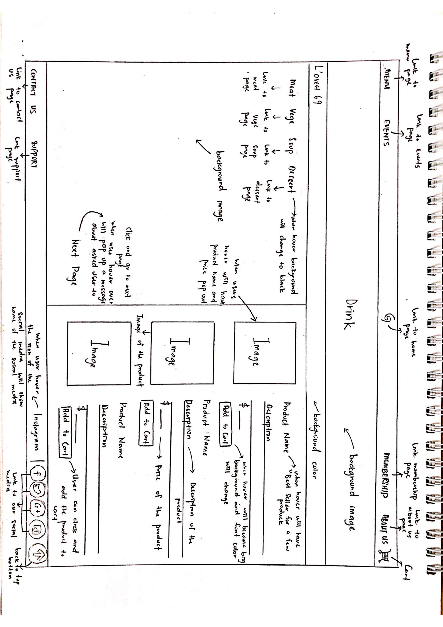

**References**

* W3schools.com, (2000). W3Schools Online Web Tutorials. [online] Available at: <https://www.w3schools.com/> [Accessed 2 Aug 2020].
* Pixel-industry.com, (2016). Royal Plate - Restaurant & Catering HTML Template. [online] Available at: <http://www.pixel-industry.com/html/royal-plate/catering.html> [Accessed 20 Aug 2020].
* Between the Bread | Full service catering and eateries in NYC(2000). Get inspired | Between the Bread in NYC. [online] Available at: <https://www.betweenthebread.com/get-inspired/> [Accessed 20 Aug 2020].
* De.Wan 1958 by Chef Wan, (2019). Events - De.Wan 1958 by Chef Wan | Wedding | Corporate | Art | Fashion. [online] Available at: <https://dewan.space/events/> [Accessed 20 Aug 2020].
* Pinterest, (2010). Keterangan foto tidak tersedia. | Desain logo, Desain, Gambar. [online] Available at: <https://www.pinterest.com/pin/829506825098629290/> [Accessed 2 Aug 2020].
* En.wikipedia.org, (2004). List of vegetable dishes. [online] Available at: <https://en.wikipedia.org/wiki/List_of_vegetable_dishes>
* Google.com, (2001). Google images. [online] Available at: <https://www.google.com/imghp?hl=EN> [Accessed 20 Aug 2020].
* En.wikipedia.org, (2001). List of soups - Wikipedia. [online] Available at: <https://en.wikipedia.org/wiki/List_of_soups> [Accessed 5 Aug. 2020].
* Jotform, (2012). 10,000+ Free Online Form Templates & Form Examples | JotForm. [online] Available at: <https://www.jotform.com/form-templates/> [Accessed 18 Aug. 2020].
* Stackoverflow.com, (2008). Stack Overflow - Where Developers Learn, Share & Build Careers. [online] Available at: <https://stackoverflow.com/> [Accessed 6 Aug. 2020].
* Developer.mozilla.org, (2005). MDN Web Docs. [online] Available at: <https://developer.mozilla.org/en-US/> [Accessed 8 Aug. 2020].
* Unsplash.com, (2013). Beautiful Free Images & Pictures | Unsplash. [online] Available at: <https://unsplash.com/> [Accessed 12 Aug. 2020].
* Pexels.com, (2014). Free stock photos · Pexels. [online] Available at: <https://www.pexels.com/> [Accessed 12 Aug. 2020].
* Pixabay.com, (2005). 1.8 million+ Stunning Free Images to Use Anywhere - Pixabay. [online] Available at: <https://pixabay.com/> [Accessed 12 Aug. 2020].
* Askideas.com, (2013). Askideas.com | Ask Ideas About Tattoos, Piercing, Food, Health, Fashion, etc. [online] Available at: <https://www.askideas.com/> [Accessed 22 Aug. 2020].
* Youtube.com, (2005). YouTube. [online] Available at: <https://www.youtube.com/> [Accessed 6 Aug. 2020].
* Codepen.io, (2015). CodePen: Build, Test, and Discover Front-end Code. [online] Available at: <https://codepen.io/> [Accessed 6 Aug. 2020].
* Seriouseats.com, (2008). *Introduction To French Macarons*. [online] Available at: <https://www.seriouseats.com/2007/10/introduction-to-french-macarons.html> [Accessed 7 August 2020].
* Pngtree, (2017). *Millions Of PNG Images, Backgrounds And Vectors For Free Download | Pngtree*. [online] Available at: <https://pngtree.com/> [Accessed 16 August 2020].
* Allrecipes.co.uk, (2012). *Reviews And Comments For Blueberry Cheesecake - All Recipes UK*. [online] Available at: <http://allrecipes.co.uk/recipe/2765/reviews-comments.aspx> [Accessed 16 August 2020].
* Shutterstock.com, (2004) Shutterstock image [online] Available at: <https://www.shutterstock.com/home> [Accessed 31 August 2020].
* En.wikipedia.org, (2004). List of steak dishes. [online] Available at: <https://en.wikipedia.org/wiki/List_of_steak_dishes> [Accessed 31 August 2020]